"My Mum, the Circus & our Family Adventures"
by MF (2018)
(About 500 words)

The other day in class, Lorena gave a beautiful and very interesting Oral Presentation on the circus. She spoke about why she loved it so much, and about the kinds of circuses there are today, being her favorite those linked to acrobatics and people using “the smallest mask ever”, which is the clown’s nose. Such a small thing transforming so radically who the wearer is!

This took me to my teenage, in the second half of the 1970s, a long time ago! -- about hundreds of the worlds back, I’d say! (The speed of light is nothing compared to human imagination in action!) It took me back to my family life, to my mother, a most extraordinary woman who led a most extraordinary life.

So here’s a little story about a period of our lives, that when the Price Circus came to town…

After my mother had married and separated twice, she decided marriage was not a good thing for her. My father had made her sexual life hell, because he was so ignorant and self-centered, and my brother’s father had stolen from her to give presents to his various lovers and also her money. However, my mother’s belief in how joyful life was could not be curtailed! She believed that friendship (with people, whether men or women) and sexual intercourse could be amazing sources of pleasure and joy, of growth too, so she decided to have friends and also lovers – or “candidatos,” “Romeos.”

Whenever a Romeo appeared in our lives, she would take her time to decide. She would give the man to different kinds of tests first, like organizing poker games to see if he was a sore loser or not; or like going places with us, her kids -- my brother, a child fixated with putting ants into concentration camps like Nazis had done with people in the Second World War, and me, a teenager, lost in outer space and with a very strong character and a great deal of rational and empathetic argumentations against injustice and abuse!

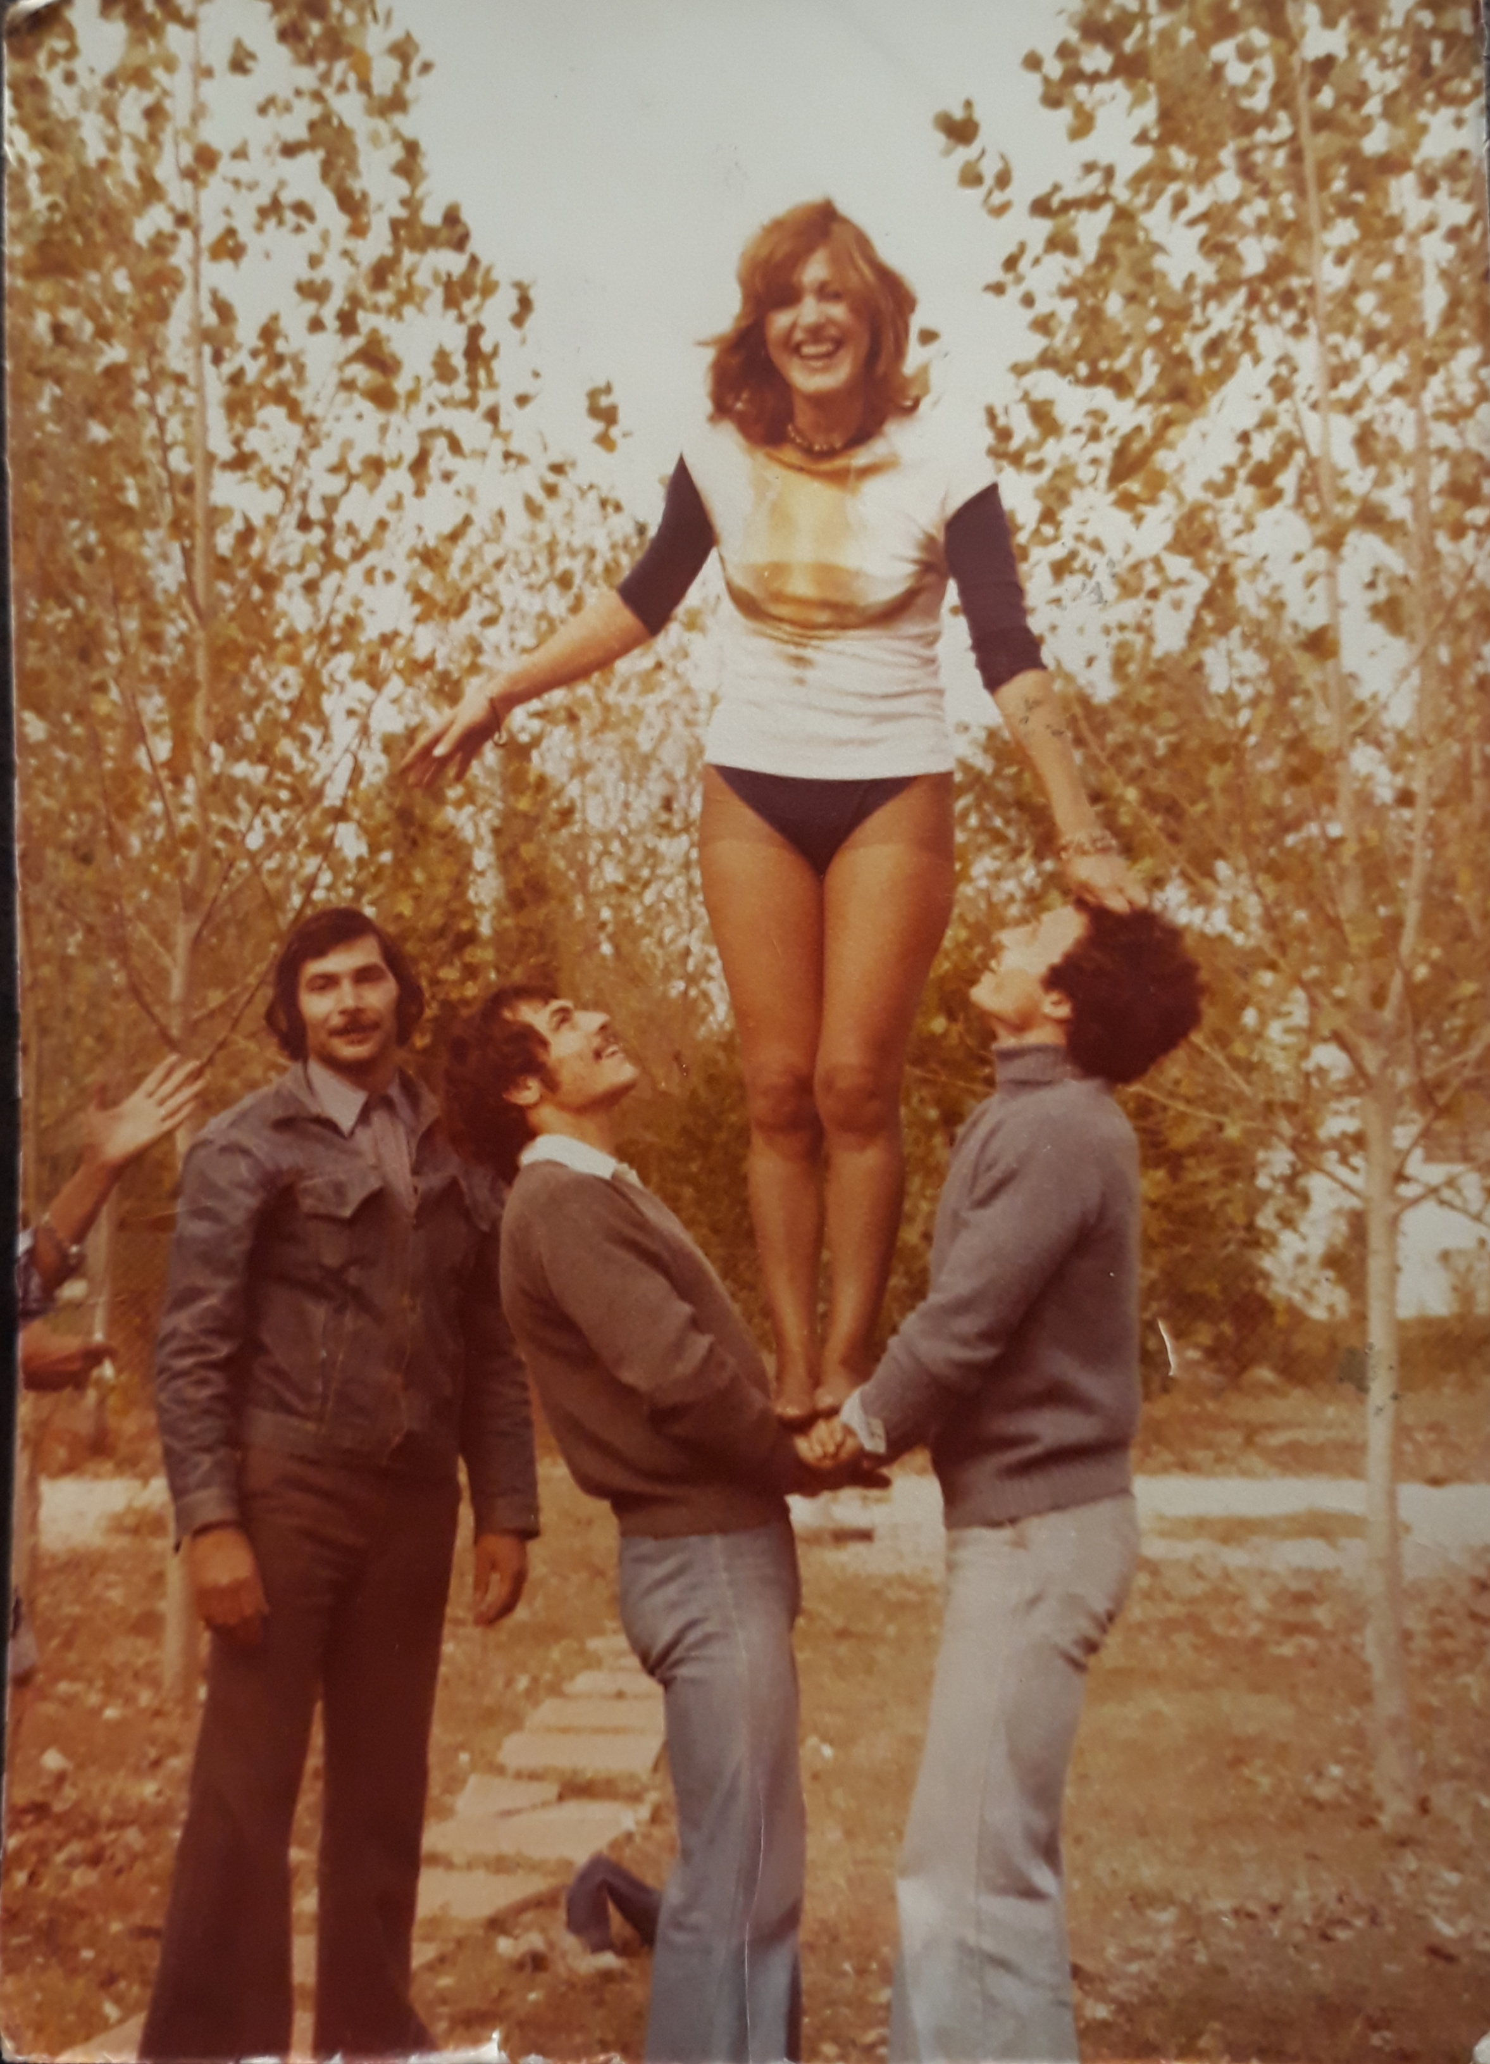
On one occasion the Price Circus arrived in town. My mother, somehow, met the leader of a Bulgarian troupe of acrobats, and my family and the whole of the troupe started spending a great deal of time together! We would often go to their rehearsals in the ring under the circus canopy tent. It was fascinating – watching them at the trapeze, or doing group acrobatics, or keeping balance on the wire. After rehearsals, we would go to their caravans or trailers, for a drink or something to eat, and at times we would share a game of poker. I remember playing one with the monkey trainer, Buffalo Bill, and some of the acrobats, plus my mother, of course! It was great fun!

When our Bulgarian friends left, they gave us their amazing show blouses, with puff sleeves and full of sequins! And that was the end to our Circus Family Adventure!

In this picture you can see my mother, with a wacky sleeveless T-shirt, a leotard underneath and the wrong kind of pantyhose, learning to keep her balance, or learning jumps, or simply having fun with some of the members of the troupe.

I’m posting some videos for students to fish vocabulary to explain all of these kinds of things in class! Here…

Videos about the circus

https://youtu.be/B-7uPEtl7RM UK English
performers and performances, acrobats doing acrobatics, rope dancers, clowns, juggling and jugglers, the ring master, the circus (canopy) tent, caravans, clown noses (made of red foam; also honking noses made of rubber plastic), the wire, the trapeze, the trampoline, the chores, the net, to hit the ground, the show, the numbers, acrobatic aerial acts,

forms of entertainment, the greatest show on earth, to put on a show, bygone times, travelling circuses, to change over the years, TV, the internet, as long as we have children we’ll have the circus,

animals were a big attraction, animal rights violation, how animals are treated, as long as they’re properly looked after, if they treat them well, provided they’re looked after correctly, wild and domestic animals, transporting animals, living in cages, training animals, sharing everyday life with animals, establish a relationship, animals given a task to do lead a more fulfilling life, animal cruelty,

When I was younger I did like the circus, it was a fun thing to do, go there!
In my heart of hearts

https://youtu.be/CtLhnbncSdM US American English
The big top ritual: raising the circus tent, hard work, a labor of love, animal trainers
Living in trailers, a budding trapeze artist (young, like a bud in a plant), a circus star, stravaganzas, numbers have dwindled, 5 rings under the big top, the show will go on, keep the circus alive, a two-hour matinee, the poodles, to curtsy

https://youtu.be/KPL_Ii4gZsY US
10 kinds of circuses today
Child-like state of wonder
Wacky performances

Explaining how to do things – Giving instructions
- https://youtu.be/5MrhUvXL3fE Learning to flip your body!
- https://youtu.be/X5P2U8YfkD4 Aerial silks acrobatics
- An interesting video where you can see a woman doing things you don’t expect women to do, think or say. We’re human, after all!
https://youtu.be/mP9U5QwPRxU

