The Mirabal Sisters & November 25
Fuengirola (Málaga, Andalucía, Spain)
Course 2020-21
Escuelas Oficiales de Idiomas (EOI Fuengirola)
en colaboración con Centros de Educación Permanente (CEPER EOI Fuengirola)
State-run language schools in collaboration with Lifelong Learning
(their communities in Fuengirola)

Mediation Project for Básico 2
In November, a group of CEFR A2 level students, 2B semipresencial, adapted to the pre-intermediate level of English an original text dedicated to the Mirabal Sisters on the blog called Rejected Princesses.com to commemorate the 25th of November, International Day Against Violence Against Women.
Students: Miriam, Noelia, Marta, M. Ángeles, José María, Verónica, Alessia, David & Trini
Teachers: Elena (CEPER) and Michelle (EOI)
Source of original text at Rejected Princesses: https://www.rejectedprincesses.com/princesses/the-mirabal-sisters
Audio support of adapted version for 2º semi students to prepare their audio/audiovisual project at ------

The Mirabal Sisters & November 25

In 1950 in Dominican Republic there was a dictatorship by Rafael Trujillo. The citizens were afraid to express their ideas until the Mirabal sisters were murdered by his agents. Their courage and the hideous murder catalyzed the end of Trujillo’s dictatorship.
The Mirabals were from a wealthy family. Minerva, Patria, María Teresa and Dede went to a Catholic school. They married kind men and had children... In short, they didn't have the profile of revolutionary women.
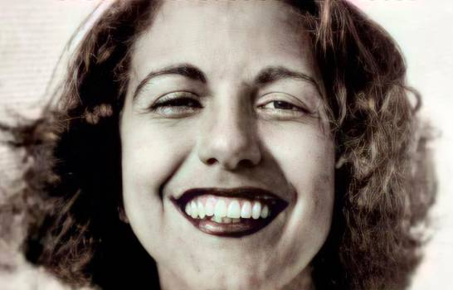
Trujillo used his power to his own advantage. He disappeared people who spoke against his rule. He sent scouts to bring girls and young women to him, and he raped many. One day the scouts sent the Mirabal sisters to one of Trujillo’s parties, and he approached Minerva Mirabal. She refused to have sex with him, in spite of the danger of saying no to a dictator.
Minerva was a brilliant student but as she started her second year at law school, she was banned from attending class until she gave a speech in favo(u)r of Trujillo. She graduated years later with the best grades but the government did not authorize her to work as a lawyer.
Shortly after Minerva said no to Trujillo, her father was arrested. After a period of torture, he was released, and he died. Later, when Minerva and her mother visited the capitol of Santo Domingo, they couldn’t leave the hotel. Trujillo wanted to have sex with Minerva before giving her freedom, but she and her mother managed to escape." Trujillo was very angry and he accused Patria, Maria Teresa and their husbands of being against him.
He spied the family and ruined them and then the Mirabal family decided to take action. After a frustrated attempt by exiled Dominicans to kill Trujillo, the Mirabals decided to continue that work. They distributed pamphlets, gathered materials for weapons, and even made makeshift bombs with the gunpowder from firecrackers around Minerva´s kitchen table. Their codename was Las Mariposas. When they tried to assassinate Trujillo in 1960, they were imprisoned. Thanks to international pressure, the women were quickly released. Trujillo designed a plan to kill them.
First their husbands were transferred to a remote jail. The only way to go there was across a mountain. The sisters knew that this was a trap but they went anyway. The secret police stopped their jeep in the mountain pass. The sisters knew they were going to get killed, so Patria ran to a nearby truck and told the driver who they were. The truck left quickly. The secret police murdered them brutally, and they tried to make it look like an accident.
This murder catalyzed the end of Trujillo. The military leaders killed him. One historian said: “the death of these women had a great effect on the Dominicans, in addition to other crimes.”
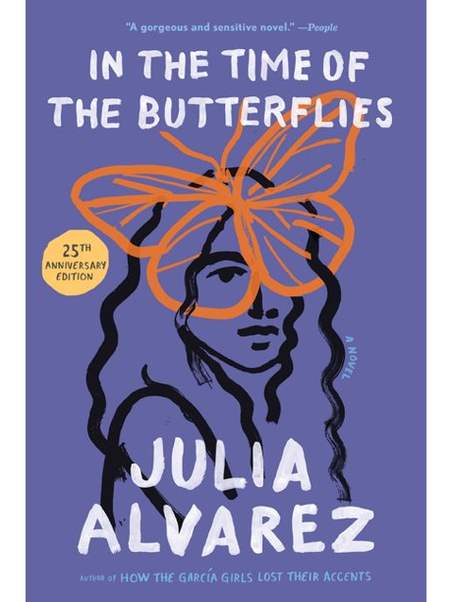
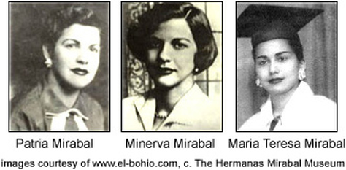
After that, the Mirabal sisters became icons for the Dominican Republic. Dedé did not participate and survived Trujillo's dictatorship. She raised her nieces and nephews, many of whom entered the government.
All Dominican towns have a commemorative marker, school, or streets with their names. Their home province was renamed Hermanas Mirabal -- instead of Ciudad Trujillo.

The novelist Julia Álvarez wrote a historical fiction novel called In the Time of the Butterflies that was adapted to the cinema.

We celebrate the Day for the Elimination of Violence Against Women on November 25th in their hono(u)r because this is the day they were murdered.

