THE MIRABAL SISTERS- 2ºB SEMI
Our courageous 2ºB semi, attending class with Elena, has tried to make a summary of the advanced text on the Mirabal sisters, and an adaptation to Pre-intermediate English, as a Mediation task.
Here is my feedback with corrections. I would also like to add the following: Try to notice how we use Capitalization and punctuation in English, including periods/full-stops, and dashes ( -- ), because it’s not like in Spanish.
About the exercise of adapting it to Pre-intermediate English: I include my work on this, so you can compare your work on this. My work is based on your selections, OK? Please, let me know if it’s useful for your work, and after that we can proceed to publication and recording!
I hope this project has allowed you all to learn a lot of English!
Thanks so much for your good work!!

The Dominican Republic in 1950 lived had a dictatorship led by Rafael Trujillo, a very evil man with a lot of evil. The nation's citizens had fear to express their opinion, until a group of sisters slapped Trujillo in the face. Finally the Nation followed their example to and ended with this man. this dictatorship.
These women were the Mirabal sisters and they gave their lives to end with Trujillo.

The Mirabals were from a good family. Minerva, Patria, María Teresa and Dede went to a Catholic school. They married good kind men and had children... In short, they didn't have the profile of revolutionary women.

(MÍRIAM)

But, Trujillo was a really bad person. He used his influence in the country to his own advantage. He made people disappear if this people talked against him. Trujillo was vicious (significa “muy malo” no “vicioso”), and he ordered to look for beautiful young girls to “have a romance” or kidnap them. Minerva Mirabal was one of those girls but she can dodge said no to him in at a party. Since that moment, she realized Trujillo could do anything with to her. (She was in danger.)
(NOELIA)
From that moment on, Minerva fought while Trujillo threatened frightened her life. She Minerva was a fabulous student but when she was starting her second year at law School, she couldn´t wasn’t allowed to attend class until she gave a speech in favor of Trujillo. She graduated years later with the best grades - summa cum laude - but she didn´t have couldn’t get a lawyer´s license because of the government didn´t permit her to develop her job.
(MARTA)
Minerva´s parents weren´t saved, either. Shortly after Minerva said not to Truijillo´s intentions, her father was imprisoned/arrested? enclosed. After a period of brutal treatment, he was released to die. Later, on a visit to the capitol of in Santo Domingo, Minerva and her mother, were placed under arrest in their hotel. Although Trujillo wanted to have sex with Minerva before giving her the freedom, finally she and her mother managed to escape."
(M. ÁNGELES)
Trujillo´s wrath didn´t stop and he accused Patria, Maria Teresa and their husbands of being activists. subversives/against him?
With the Mirabal Family economy ruined due to Trujillo’s interferences and spying every word they said, the Mirabal family decided to take action. They made a total rebellion that came after a frustrated attempt by exiled Dominicans to eliminate Trujillo.
The Mirabals decided to continue the that work or to help by distributing pamphlets, gathering materials for weapons, and even Mmaking improvised bombs with the gunpowder of firecrackers around Minerva´s kitchen table. The three activist sisters became known as “Las Mariposas”.
(JOSÉ Mª)
When they tried to assassinate Trujillo in 1960, they were thrown in jail. Thanks to international pressure, the women were quickly released. When Trujillo´s political fortunes continued to worse, he blamed the Mirabal sisters for all his problems. And so he ordered them killed.
(VERÓNICA)
The Mirabal sisters were assassinated because of Trujillo's trap. First, Trujillo transferred their husbands to in a remote jail because -- the only way to go there was across the mountain. The sisters knew that this was a trap but they went anyway. The secret police stopped their jeep in the mountain pass. They knew they were going to die, so Patria ran to a nearby truck and told the driver who they were and finished quickly the affair. After that, the truck went left quickly. (drove away / sped away)
(ALESSIA)
The Mirabal sisters were killed for by the secret police. They tried to make it look like an accident. The evidences said otherwise. The Mirabals’ deaths served to eliminate Trujillo. The military leaders killed him. One historian said: “the death of these women had a great effect on the Dominicans, in addition to other crimes. … They could never forgive Trujillo this crime”.
(DAVID)
After that, the Mirabal sisters became hallowed icons for the Dominican Republic. Dedé did not participate and survived the Trujillo's dictatorship reign. She raised his her nieces and nephews, many of whom entered the government.

All Dominican towns has have a commemorative marker, school, or streets with her their names. Their home province was renamed Hermanas Mirabal -- instead of "Ciudad Trujillo". (FABIO)

The novelist Julia Álvarez wrote a historical fiction novel called “The Time of the Butterflies” that is adapted to the cinema. We celebrate the Day for the Elimination of Violence Againts Women on November 25th in their honour and because it coincides with this is the day they died were murdered.
(TRINI)

The Mirabal Sisters & Nov 25
Text adapted to Pre-intermediate English selected and worked on by https://www.rejectedprincesses.com/princesses/the-mirabal-sisters

Teachers: Elena (CEPER) and Michelle (EOI) Fuengirola, course 2020-21 Original read out by Michelle at https://youtu.be/2pMI4An_aYg
Mediation Project for Básico 2: Adapting an original text dedicated to the Mirabal Sisters, commemorating the 25th of November, International Day Against Violence Against Women, to the pre-intermediate level of English.
Authors (2ºB semipresencial, 2020-21) Miriam, Noelia, Marta, M. Ángeles, José María, Verónica, Alessia, David, Trini.
In 1950 in Dominican Republic there was a dictatorship by Rafael Trujillo. The citizens were afraid to express their ideas until the Mirabal sisters were murdered by his agents. Their courage and the hideous murder catalyzed the end of Trujillo’s dictatorship.
The Mirabals were from a wealthy family. Minerva, Patria, María Teresa and Dede went to a Catholic school. They married kind men and had children... In short, they didn't have the profile of revolutionary women.
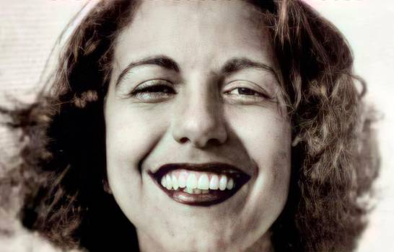
Trujillo used his power to his own advantage. He disappeared people who spoke against his rule. He sent scouts to bring girls and young women to him, and he raped many. One day the scouts sent the Mirabal sisters to one of Trujillo’s parties, and he approached Minerva Mirabal. She refused to have sex with him, in spite of the danger of saying no to a dictator.
Minerva was a brilliant student but as she started her second year at law school, she was banned from attending class until she gave a speech in favo(u)r of Trujillo. She graduated years later with the best grades but the government did not authorize her to work as a lawyer.
Shortly after Minerva said no to Trujillo, her father was arrested. After a period of torture, he was released, and he died. Later, when Minerva and her mother visited the capitol of Santo Domingo, they couldn’t leave the hotel. Trujillo wanted to have sex with Minerva before giving her freedom, but she and her mother managed to escape." Trujillo was very angry and he accused Patria, Maria Teresa and their husbands of being against him.
He spied the family and ruined them and then the Mirabal family decided to take action. After a frustrated attempt by exiled Dominicans to kill Trujillo, the Mirabals decided to continue that work. They distributed pamphlets, gathered materials for weapons, and even made makeshift bombs with the gunpowder from firecrackers around Minerva´s kitchen table. Their codename was Las Mariposas. When they tried to assassinate Trujillo in 1960, they were imprisoned. Thanks to international pressure, the women were quickly released. Trujillo designed a plan to kill them.
First their husbands were transferred to a remote jail. The only way to go there was across a mountain. The sisters knew that this was a trap but they went anyway. The secret police stopped their jeep in the mountain pass. The sisters knew they were going to get killed, so Patria ran to a nearby truck and told the driver who they were. The truck left quickly. The secret police murdered them brutally, and they tried to make it look like an accident.
This murder catalyzed the end of Trujillo. The military leaders killed him. One historian said: “the death of these women had a great effect on the Dominicans, in addition to other crimes.”
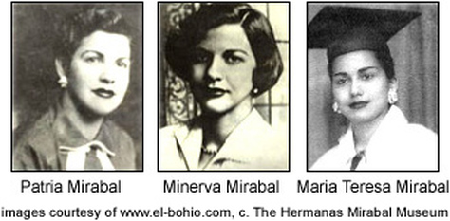
After that, the Mirabal sisters became icons for the Dominican Republic. Dedé did not participate and survived the Trujillo's dictatorship. She raised her nieces and nephews, many of whom entered the government.
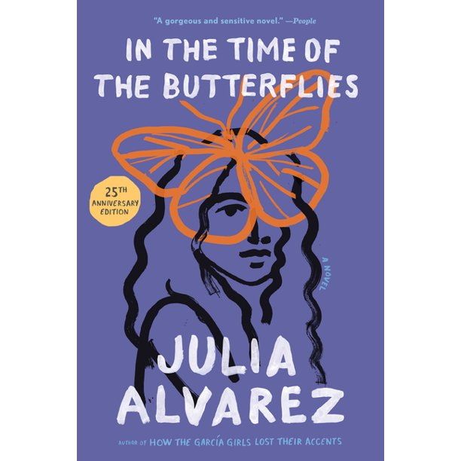
All Dominican towns have a commemorative marker, school, or streets with their names. Their home province was renamed Hermanas Mirabal -- instead of Ciudad Trujillo.
The novelist Julia Álvarez wrote a historical fiction novel called In the Time of the Butterflies that was adapted to the cinema.
We celebrate the Day for the Elimination of Violence Against Women on November 25th in their hono(u)r because this is the day they were murdered.

