COUNTRIES, NATIONALITIES & LANGUAGES
Name: __________________________________________________________________________
Group: _________

Dear students,
Highlight /hailait/ the C-N-L you want to learn and practice/practise saying that till you know it well!

CAN YOU HELP? HELP US COMPLETE THIS LIST!

PRACTICE/PRACTISE WITH THESE STRUCTURES

People from (country) are (nationality) and they speak (language)

Where do you come from? I come from (country) / I’m from (country) / I’m (nationality)
Other people: Where is she from? Where is he from? Where are they from?

Country | Nationality | Language
Afghanistan | Afghan | Persian - Pashto
Algeria | Algerian | Arabic, Bereber
Angola | Angolan | Portuguese
Argentina | Argentinian | Spanish
Australia | Australian | English
Belgium | Belgian | French / Flemish
Bolivia | Bolivian | Spanish
Burkina Faso | Burkinabé | French + many languages
Brazil | Brazilian | Portuguese
Britain / The UK | British: English in England, Scottish in Scotland, Welsh in Wales, British/Irish in Northern Ireland | English + Scotts / Scottish Gaelic, Welsh, Irish Gaelic
Bulgaria | Bulgarian | Bulgarian
Cape Verde | Cape Verdeans | Portuguese + many languages
Cambodia | Cambodian | Cambodian
Cameroon | Cameroonian | French / English + many languages
Canada | Canadian | (Canadian) English / (Canadian) French in Quebec (primarily)
Chile | Chilean | Spanish
China | Chinese | Chinese
Colombia | Colombian | Spanish
Costa Rica | Costa Rican | Spanish
Croatia | Croatian | Croatian (Serbocroatian)
Cuba | Cuban | Spanish
Denmark | Danish (Dane) | Danish
Dominican Republic | Dominican | Spanish
Ecuador | Ecuadorian | Spanish
Ecuatorial Guinea | Ecuatorial Guinean | Spanish, French, Portuguese + many languages
Egypt | Egyptian | (Egyptian) Arabic
El Salvador | Salvadorian | Spanish
Estonia | Estonian | Estonian
Ethiopia | Ethiopian | Amharic
Finland | Finnish | Finnish
France | French | French
The Gambia | Gambian | English, Mandinka + many languages
Germany | German | German
Ghana | Ghanaian | English
Guinea Bissau | Bissau-Guinean | Portuguese
Greece | Greek | Greek
Guatemala | Guatemalan | Spanish + 22 ethnic groups many of which have their own language, like Quiché, Ixil, Kaqchikel
Haiti | Haitian | French / Creole
Honduras | Honduran | Spanish
India | Indian | Hindi / English
Indonesia | Indonesian | Indonesian
Iran | Iranian | Persian
Ireland | Irish | Irish / English
Israel | Israeli | Hebrew
Italy | Italian | Italian
Ivory Coast | Ivorian | French + many languages
Japan | Japanese | Japanese
Jordan | Jordanian | Arabic
Kenya | Kenyan | Swahili
Korea | Korean | Korean
Laos | Laotian | Laotian
Latvia | Latvian | Latvian
Liberia | Liberian | English + many languages
Lithuania | Lithuanian | Lithuanian
Malaysia | Malaysian | Malay / Malaysian
Mali | Malian | French / Bambara + many languages
Mauritania | Mauritanian | Arabic / French
Mexico | Mexican | Spanish
Morocco | Moroccan | Arabic / French
The Netherlands | Dutch | Dutch
New Zealand | New Zealander | English / Maori
Nicaragua | Nicaraguan | Spanish
Nigeria | Nigerian | English + many languages
Norway | Norwegian | Norwegian
Panama | Panamanian | Spanish
Paraguay | Paraguayan | Spanish
Peru | Peruvian | Spanish / Quechua
The Philippines | Filipino | Tagalog / Filipino / Spanish / English
Poland | Polish | Polish
Portugal | Portuguese | Portuguese
Puerto Rico | Puerto Rican (Caribbean island, US Territory) | Spanish
Romania | Romanian | Romanian

Russia | Russian | Russian

Rwanda | Rwandese / Rwandan | Kinyarwanda
Saudi Arabia | Saudi | Arabic
Senegal | Senegalese | French + many languages
Serbia | Serb | Serbian (Serbocroatian)
Sierra Leone | Sierra Leonian / from Sierra Leone | English + many languages
Somalia | Somalian / Somali | Somali / Arabic
Spain | Spanish + Catalan in Catalunya / Galician/Galego in Galicia / Basque in the Basque Country  15 Autonomous Communities in all, including Andalucian in Andalucía, and 2 Autonomous cities, Ceuta and Melilla | Spanish  (14 languages: 3 sign languages)
Syria | Syrian | (Syrian) Arabic
Sweden | Swedish | Swedish
Switzerland | Swiss | (Swiss) French / German / Italian
Taiwan | Taiwanese | Chinese
Thailand | Thai | Thai
Turkey | Turkish | Turkish
Ukraine | Ukrainian | Ukrainian
The United States | (US) American / from the USA | English
Uruguay | Uruguayan | Spanish
Venezuela | Venezuelan | Spanish
Vietnam | Vietnamese | Vietnamese
Zaire | From Zaire | French, Swahili
The Caribbean: more than 700 islands – some
Languages: Spanish, English, French, Dutch, and more! It’s crazy!
The Sahrawi people (languages: Arabic, Spanish)
The Tuareg
Roma people (worldwide) / Gypsies (in Spain)
The Palestinian people / The Gaza Strip
First Nations / Pueblos originarios (nations in America like the Innuit, the Dakota, Quiché, Mapuche...)
Aborigines (Australia)
The Saami people (Finland, Norway, Sweden, Russia)
The Kurds
The Joruba / The Igbo (Nigeria)
Tibetan people (China)
Scottish / Welsh (Britain)
Mapuche people (Argentina, Chile)
Catalan / Galician / Basque / Andalusian / Canarian (Spain)
Maori people (Australia)
Hawaiian people (the USA)

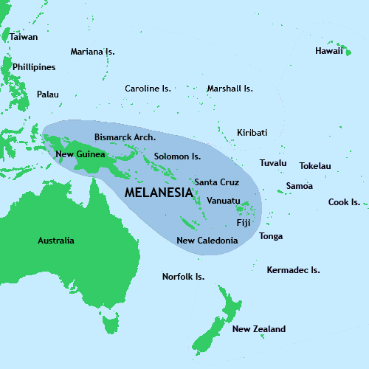
Most people in the world speak two or three languages.

Western Europe is not a language hotspot, because very few languages are spoken in comparison to other areas of the world.

New Guinea (Papua Island) is the world’s most important language hotspot, with over 800 languages spoken!!

