Hidden Figures (movie/film) Dialogues for Levels A2-B1-B2-C1

Book published June 2016. Movie released in the USA in December 2016!

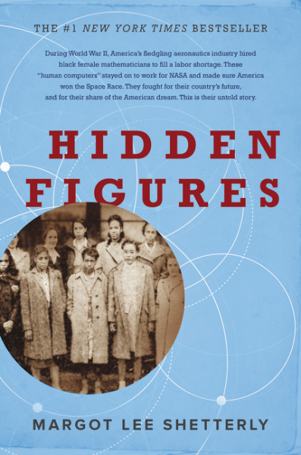
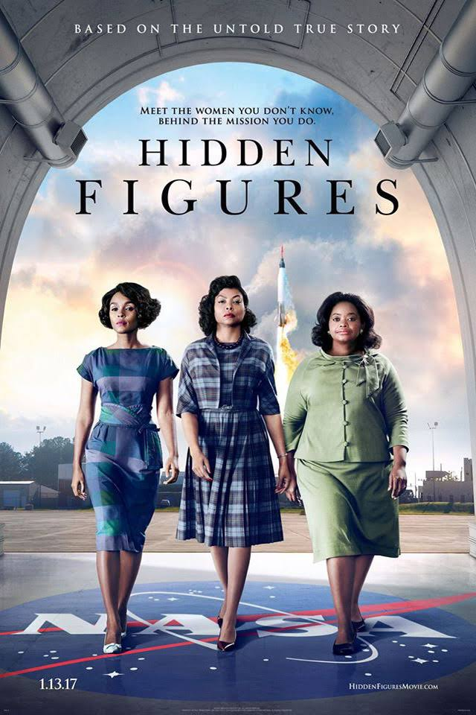

Básico (Elementary, Pre-intermediate)
Reviewing: invitations, arranging to meet, talking about general truths, things that are happening, and talking about people and events in the past, plus expressions.

A: Hello!
B: Hi! How are you?
A: Fine! And you?
B: Very well, thanks! Where are you going?
A: I’m going to the beach, for a walk.
B: Would you like to go for a drink?
A: Great! Where can we go?
B: To the Miramar Mall / Shopping Centre. We can walk. It’s near here!
A: I don’t like malls/shopping centres, but it’s true, it’s near here! Let’s go.

B: Hey, look! They’re showing “Hidden Figures”!
A: What’s that?
B: It’s a movie/film about three scientists!
A: Is it good?
B: I don’t know, but it sounds very interesting!
A: Why? What did they do?
B: They were women and black, so they’re not famous. But their work was very important for NASA, the US American space agency.
A: Well, it sounds interesting!
B: I’d like to see it! / I want to see it!
A: Me too! Let’s go together!
B: Great idea! When can we meet?
A: I’m free tomorrow evening. Are you free then?
B: I have to go to bed early. But we can go in the afternoon! There is a session at 5.45…
A: Good! And, hey, we can tell our friends, too!
B: Great! I can call María and you can call Juan.
A: OK! Can I call my friend Gretta, too? She’s really nice and she is a feminist!
B: Of course! Then we can meet her! And after the movie/film, we can ask her about the movie/film!
A: She’ll love that! See you tomorrow at 5.30!
B: Yes, outside the Miramar movie theater/cinema, OK?
A: OK! Bye!
B: See you soon!
Upper Intermediate (B2)

A: Hello!
B: Hi there! Nice to see you! How are you?
A: Hi! I’m very well. Thanks! What about you?
B: I’m very busy at work, as usual, but fine, thanks. Do you have time for a drink?
A: Definitely! Where would you like to go?
B: There’s a good place near here. It’s got nice tapas, and it’s not very expensive.
…
B: So how’s life?
A: Life is fine. I just need a job!
B: Oh, really? Didn’t you have one?
A: The boss made a pass at me, I rejected him, and then… Well… I decided I did not want to see him again, so I left.
B: Oh, I’m sorry to hear that. Did you report him?
A: No, I didn’t. Anyway, it wasn’t a good job. And the pay was really low…
B: Well, if you need to cheer up, you must watch “Hidden Figures”!
A: Why? Is it a comedy?
B: No, hahaha… But it’s a very inspiring true story.
A: What’s it about?
B: It’s about three scientists who were women and black, so NASA didn’t write their names in history.
A: Outrageous!
B: Yes, it was! Their work was crucial for the space program(me), though.
A: So how did we learn about these women?
B: We know this story because a woman wrote it just one year ago! Her name’s Margot Lee Shetterley.
A: Just a year ago? Wow… Something that important, right? They should be famous not only for that, but also for having made it that far!
B: Anyway, about the story, I was impressed by these women’s strength, intelligence and sense of humo(u)r.
A: No wonder! I imagine they were very brave...
B: Yes! Racism and sexism were much worse than today back in the 1950s. When the police stopped people, you never knew what was going to happen. Actually, the movie/film starts with a tense scene about an encounter of these women with the police.
A: Oh, does that have a happy ending? I can’t stand violence in movies/films!
B: Yes, don’t worry! That’s something that relieved me a great deal! But now I spoiled/’ve spoiled all the tension for you!
A: Don’t worry. I’m not into tension much either! Hahaha
B: Then universities were segregated and some didn’t accept women. There’s an amazing scene around this question.
A: Our lives have changed a lot in the last 50 years, but that is nothing in terms of history!
B: These women, well, they just found the way to become really good professionally and get the jobs they wanted. They were very intelligent in different ways. And funny, too!
A: They should be admired, really! OK, then, I really need to see this movie/film.
B: I saw it in Spanish, but I’d like to see it again in English.
A: Why don’t we go together? I’d love to see it in English!
B: Great! Where’s it on?
A: Let’s see... Here! And there’s a session in 45 minutes! In English!
B: I’m free! I can go and watch it!
A: Let me call home and see if I can stay! … Hi, love! Hey, listen, I’ve bumped into a friend and she/he’s recommended a movie/film they are showing in 45 minutes! Is it OK if I stay to watch it? I mean, I was supposed to cook dinner tonight! … OK, thanks! You’re adorable! … Thanks! See you in about four hours, then! Bye!
B: Wonderful! We’re going to the cinema!
A: Let me pay for this!
B: OK, but I’ll get the tickets, then!

Advanced (C1)

A: Hi there!
B: Hey, hi! Long time no see! / It’s ages since we last met!
A: Yes, hahaha! How’re you doing?
B: Not bad! What about you? Any news?
A: I had a baby!!
B: Really?! Congrats! What’s its name?
A: Alexa! It’s a girl. And she’s really cheerful and quiet, for a baby, I mean!
B: Then she’s just like you, right? – Do you have time for a drink, now?
A: Sure! Let’s go over there, there’re some great tapas! -- So how’s life? What have you been up to?
B: Not much. No news, really…
A: Do you still have that terrible boss?
B: Yes, hahaha! What a nightmare! But I’ve grown used to him.
Hey, look! Have you seen that movie?
A: Nope! Is it any good? What’s it about?
B: It’s about these women who just found the way to become really good professionally in spite of all the racism and sexism in their times. They were scientists doing relevant work for NASA in the space program(me) but they didn’t make it to history because they were women and black. Not even NASA had acknowledged their work in their records!
A: Wow… When was that? When did these women live?
B: The 1950s or so… One was the best mathematician in the country, another became the first black woman engineer who was allowed to attend a certain university and another learned/learnt to program(me) NASA’s first computer in her free time, and well… You must see this movie/film!
A: Once I read about “the computers”, but it was white women. They had also been ignored in the history of NASA or the USA, for that matter!
B: Those women are in the movie, too. They aren’t too nice to black computers either…
One of the things that impressed me the most in this story is that although it’s been some years since we learned about the white computers, black women scientists were still totally out of history till June 2016 when the book was published! That’s when the writer who had known them as a little girl -- because her dad was a scientist working for NASA -- wrote their story. Can’t remember her name just now…
A: Are you kidding?! I know women’s history is almost non-existent, but I thought we knew what can actually be known from research!
B: Well… Racism & sexism are still operating… We can’t overcome centuries of that in less than one, I mean.
A: Absolutely. Tell me a bit more about the movie...
B: There are some really good scenes, mostly about these women’s thoughts & actions. What impressed me most was how cheerfully they persevered in the face of hardship, and their brilliant intelligence! How they found their way in a very hostile environment. I particularly enjoyed one shot in the women’s toilet at NASA.
A: So what was that?
B: This white supervisor and one of the main characters (the one that’s become an expert at programming so they’ve had to promote her to supervisor, as she had long been requesting) are there and the white supervisor says something like “It was nothing personal, you know”, like meaning she was not the racist person she had been all the way, hahaha, and the black woman (now a supervisor too) replies, “I’m sure you believe that” as a way of accepting her apologies, but posing the critical point, too. So intelligent!
A: Gee, I’m dying to watch it! It reminds me of people’s attitudes to feminism! Nobody’s sexist anymore today, they say! As if that were possible in a world with 20 centuries of patriarchal values! As if we, feminists, were crazy or evil, bringing up unexisting issues, “complaining” for nothing, hating men, the whole lot of terrible things conscious and unconscious sexist people say about us.
B: Well, this is the kind of story that anyone can watch today and enjoy, because most people agree – at least in theory – that racism is bad, so spectators are able to relate to the protagonists. And that’s good because then it’s easier to find similarities with sexism, or to realize what feminist struggle is about.
A: Yes, there are a great deal of parallelisms between racism and machismo.
B: Anyway, if you’ve got friends who need cheering up, get a boost of self-confidence or energy to fight or something, they’ll probably find inspiration in this movie/film, too. It’s very empowering for us all, you know.
A: Well, I’m sure to go, with Manuel, too.
B: Just remembered the name of the writer – Margot Lee Shetterley. I’d like to read the book next.
A: Is it in Spanish? (looking at watch) Ohmy! I forgot it’s my turn to cook dinner! I need to rush home!
B: Haha… It’s OK! Go along! I’ll call you tomorrow so we can arrange to meet some day…
A: Great! See you then!

