Become a Writer * Workshop
By michelle (2004-2008)
Intermediate

Warm-up (4 pages): Some English-Speaking Writers

Workshop “Become a Writer”:
Do the activities and, if you like, send them for publication
to Talking People
 Poetry. An inspiring presentation focused in visual poems (1 page)
 Food for Thought deals with interesting quotes and posters (1 page)
 Writing Stories deals with narrative and descriptive creative texts (9 pages, including resource material)
 The AntiWriters Contest! (2 pages)
 Writing Argumentative Texts deals with short pro-con essays. (2 pages)
 Writing Rubric (assessment) (1 page)

Types of texts you will be working with: poetry, aphorisms, drafts, fiction writing (narrative and descriptive, dialogues), argumentative. For more possibilities, see page 9.

BECOME A WRITER
* Poetry is Free. * Writing Stories. * Writing Argumentative Texts

POETRY WORKSHEET

Read Tzara’s dada instructions and stick your dada poem here:

HOW TO MAKE A DADAIST POEM
- To make a Dadaist poem:
- Take a newspaper.
- Take a pair of scissors.
- Choose an article as long as you are planning to make your poem.
- Cut out the article.
- Then cut out each of the words that make up this article and put them in a bag.
- Shake it gently.
- Then take out the scraps one after the other in the order in which they left the bag.
- Copy conscientiously.
- The poem will be like you.
- And here you are a writer, infinitely original and endowed with a sensibility that is charming though beyond the understanding of the vulgar.
Tristan Tzara

Poetry has often used typographic resources to add meaning to words. Inspired in calligrams by Apollinaire, we now also have Visual Poetry. Look at these poems, entitled “Blues” by Eleanor Nichol (http://www.thing.net/~grist/l&d/bpnichol/ky-ebp01.htm)
And “A Human Document” by Tom Phillips (http://rosacordis.com/humument/index2.html).
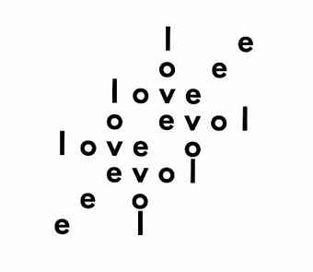 | What do you feel or think of when you see these visual poems?  Choose words and make your own… | 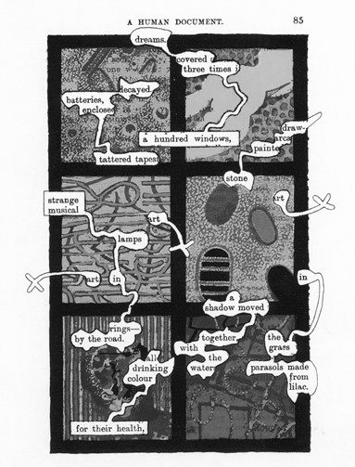
FOOD FOR THOUGHT: INTERESTING SLOGANS OR QUOTES

Look at the poster.

Read these quotes by artists and other thinkers! Use one to make a poster or make up your own.
(Web Page Source: Quote posters at The Kennedy Center for Performing Arts. ArtsEDGE)

Creativity takes courage. Henri Matisse (painter)
The dance is a poem of which each movement is a word. – Mata Hari (dancer)
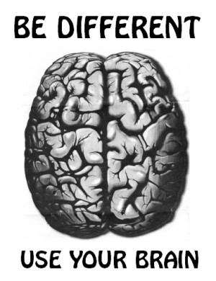

Go confidently in the direction of your dreams. Live the life you’ve imagined. – Henry David Thoreau (philosopher)
Words are, of course, the most powerful drug used by mankind. – Rudyard Kipling (writer)
Dancing is like dreaming with your feet. – Constanze (dancer)
Without music, life is a journey through a desert. – Pat Conroy
I try to apply colors like words that shape poems, like notes that shape music. – Joan Miro (painter)
There is always music amongst the trees in the garden, but our hearts must be very quiet to hear it. – M. Aumonier
The aim of art is to represent not the outward appearance of things, but their inward significance. – Aristotle (philosopher)
Countless unseen details are often the only difference between mediocre and magnificent. – Anonymous
Dance first. Think later. It’s the natural order. – Samuel Beckett (writer)
Art is the symbol of the two noblest human efforts: to construct and to refrain from destruction. – Simone Weil (woman philosopher)
Nothing you write, if you hope to be any good, will ever come out as you first hoped. – Lillian Hellman (writer)
Art is either plagiarism or revolution. Paul Gaugin (painter)
Do not fear mistakes, there are none. – Miles Davis (musician)
Anyone who has never made a mistake has never tried anything new. – Albert Einstein (scientist)
Creativity is allowing yourself to make mistakes. Art is knowing which ones to keep. – Scott Adams
Good art is not what it looks like, but what it does to us. – Roy Adzak
Music was my refuge, I could crawl into the space between the notes and curl my back to loneliness. – Maya Angelou (writer)
Anyone who says sunshine brings happiness has never danced in the rain. – Anonymous
BECOME A WRITER!
* Poetry is Free. * Writing Stories. * Writing Argumentative Texts

WRITING STORIES

Writers are professional story-tellers. They use their life experiences and imagination to create stories. First, they have an idea, something to communicate, and then they sit and write about it. It is true they often use inspiration, but it is also true they need to have writing skills.

Writers think a lot about how they can tell their story in the best way. This includes:
- Stories must offer readers their INSIGHTS of the world.
- Stories must cause feelings, EMOTION.
- Stories must have a CORRECT WRITTEN FORM.

Writing is not Speaking. Readers cannot see you, they do not know what you know, what you are thinking of, unless you tell them. When we write a story, we cannot use our gestures, nor our voice. We cannot point at things. We depend wholly on written words, spelling and typographic signs (periods, comas, the colon, the semi-colon, question marks, the dash, italics, paragraphs…).

You’ll have to consider:
- Subject: choose the right subject for you, something you know about, something that makes you feel something! Be clear about this: What’s your point? What do you want to communicate, in essence?
- Form: you’ll have to work on the beginning, the shape of your story or essay, the ending, and choosing a good title!
We are going to learn to write a story. We will consider:
- Having ideas: brainstorming
- Organizing them: selecting them and ordering them
- Expressing them effectively: coherence, emotion

Let’s start!

- Select a TOPIC. Use the BRAINSTORMING technique.
 Do the GATHERING IDEAS worksheet (page 5)
- THINK of the fundamental material of your STORY: Do you want to narrate events, describe people, things, places? Both combined? In what tone?
 AND  TIPS ON TONE & GENRE
From what approach? (Who and where is the narrator?)
 AND  TIPS ON APPROACH AND NARRATOR
BECOME A WRITER!
* Poetry is Free. * Writing Stories. * Writing Argumentative Texts

GATHERING IDEAS WORKSHEET

The Brainstorming Technique
Like Surrealist artists, when you start thinking of your story, jot down FREELY (without an order) anything that comes to your mind! How?
 Do your drafts and clip them to this project. Now you are NOT going to write a story, you are just going to brainstorm.

* The fundamental questions
Where? When? Why? How? Who? What? …

* The senses
Another way of calling forth ideas is to take each of the senses in Turn and see whether it can be fruitful when applied to your topic. The senses are sight, hearing, touch, taste and smell.

* Free Association. You can also use the free association technique. Some examples:

Game of the 16 words: What’s your present mood?
Write 16 words quickly, without thinking, one under the other, in a column.
Next, what’s the word you freely associate with the first pair of words in your column? What word do you get from the next pair? Continue like this till your 8th pair.
Follow the same process till you get to one single word. That resulting word is related to your present mood. Of course, you have to do this game in Spanish, but it can help you produce ideas for your story.

Chained words
A free association chain of words where the following word begins with the last letter of the preceding word: felicidad, dadaísta, amor, rojo, óleo, olor, ramos, sapo, ostra, alegría, astigmatismo, óleo, ogra, asco, ostra, astro, olmo, ole, elefante, explicación, nada, asteroide…
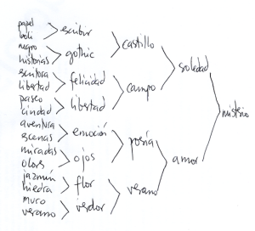

Charts can be very useful, when you have identified the TOPIC OF YOUR STORY. Choose two ideas for the vertical and horizontal axis and fill in the cells with the ideas you associate to the two concepts:

TOPIC: LA GUERRA
Colores  Situaciones | ROJO | NARANJA | AMARILLO | VERDE | AZUL | NEGRO | BLANCO
GUERRA | sangre | sopa de calabaza | enfermedad | prados | cielo | hombres | sucio
A lo mejor aquí ya se te han ocurrido algunas ideas, incluso partes de una historia...
DOLOR | herida | amor | hospital | náusea | tristeza | muerte | nada
Y aquí vas añadiendo, descartando otras anteriores, desarrollando...
PASADO | sandías | alegría | enfermedad | prados | lluvia | hormigas | sábanas
PRESENTE | sangre | sopa | enfermedad | envidia | enfermedad | muerte | muerte
FUTURO | amor | alegría | luz | bosques | cielo, mar | martillo | sábanas
Resources in the web. Cómo escribir composiciones y Cómo generar ideas: http://mujerpalabra.net/secundaria/pages/metodologia
BECOME A WRITER!
* Poetry is Free. * Writing Stories. * Writing Argumentative Texts

Tips on TONE/ATMOSPHERE
What ATMOSPHERE do you want to create? What FEELINGS do you want to cause in the reader? At what times? How can you achieve this?
Think of Edgar Allan Poe’s tales, for instance. Poe creates tension not only through the narration of EVENTS (a man murders a woman). It is also the way he describes PEOPLE (character description) and PLACES (the description of settings, like dark or remote places). The atmosphere also relates to the selection of VOCABULARY. And another important factor is PROGRESSION or NARRATIVE RHYTHM: WHEN you say WHAT (the sequence of events). What information goes first, at what pace (narrative rhythm) will you present the information? What goes last?
 Jot down your thoughts on this…
Tips on GENRE

The tone is closely linked to another issue. What will your story be?
A comedy
A tragedy
A tale of mystery
An adventure story
A SF story
A realist story
A detective story or a crime
A romance
We can also take advantage of other types of texts to create fiction:
A press article
A letter
A diary extract
A scientific report
A film/comic script
An philosophical essay…
Dialogues
Announcements

 What are YOU going to do?
Answer as in the example: I’m going to write a SF story. I’m going to add the protagonists’ diary extracts and passages from a scientific report.
…………………………………………………………………………………………………………………………………………………………………………………………………………………………………………………………………………………………………………………………

PROJECT BECOME A WRITER!
* Poetry is Free. * Writing Stories. * Writing Argumentative Texts

Tips on APPROACH and NARRATOR
Visualize your story. Who is the narrator? Where is the narrator standing? Will the narrator address anyone? The point of view is very important to make your story coherent (making sense). Here are some useful tips for a good and solid approach.

Chronological (Time)
You know more than you think you do. When you write a diary, or a letter to a friend, you organize your text chronologically. When you tell a story you do the same: you start at the beginning and keep going till the end. This is a natural, intuitive way to organize a text. If you follow the chronological approach you won’t get lost!

Camera-Eye (Spatial)
You can choose the visual. You can tell your story imagining you are a camera: what do you focus first? What do you focus next?
You can start with a general panoramic and then use your zoom to focus gradually in the scene, this is, you can describe from the general to the specific. You can also start describing the scene from your left and move your camera slowly to the right, describing what you see on your way.

Thematic
You can also describe or narrate things following a list of themes or categories. You could focus on people or people’s activities.
I’m going to write about Pixie’s life. How can I? I could talk about her family first, then about her activities, then about her friends, her likes and dislikes…

Combining approaches
Usually we choose one parting approach and then use others. (Look how different Pixie’s story would be organized in this mixed way):
Pixie’s story |  | 2. Spatial approach | 3. Thematic approach
1. Chronological approach | In the morning | At the school entrance  In the corridor | Friends and classmates
1. Chronological approach | In the morning | In the classroom | Teachers
1. Chronological approach | In the morning | During the break | Talking about boys
1. Chronological approach | In the morning | In the classroom | Exams
1. Chronological approach | In the morning | Leaving school | Talking about parents
1. Chronological approach | In the afternoon | …
1. Chronological approach | In the evening | …
1. Chronological approach | At night | …
 You probably know all this intuitively. Just be aware, so you can use it to improve your writing!

One more thing: Add a pinch of originality
Your point of view can be amazing, even if the story is not very special. Consider these examples: The teacher tells you to write an essay on life at school, and that bores you to death. But… what about if your point of view is that of a piece of chewing gum stuck under someone’s desk? How would that piece of gum see life at school? The teacher tells you to write about the mad cows disease. You don’t know anything about it! Wait a moment, you do! You don’t know the political stuff, but… what about the cows: why don’t you write your story from the cow’s point of view? ☺
PROJECT BECOME A WRITER!
* Poetry is Free. * Writing Stories. * Writing Argumentative Texts

COHESION AND COHERENCE
You will have to think of TEXTUAL STRUCTURE and the LANGUAGE you will use. After jotting down all your ideas, you have to select them and organize them into a convincing whole. You may have to discard some ideas. Don’t be afraid of crossing out things, it may be better for your text.

- COHESION refers to the tools you will use to create UNITY in your text. With WORDS you will build sentences. With SENTENCES you will build paragraphs and with PARAGRAPHS you will build your TEXT. All of these have to build a unit.
- COHERENCE refers to MAKING SENSE. You must be clear about what you want to express—the STORYLINE and its effect on readers.

You must offer your text a STRUCTURE to contain and develop the story. How can you do this? A typical storyline structure is: setting + development + resolution. Sometimes writers add a coda, a comment that brings readers back to the real world.

NOW LET’S START WITH THE STORY!

 FIRST DRAFT (In Spanish)
1. Choose a topic. What do you want to write about?
2. Brainstorming. Write down all the ideas you can think of around that topic.
3. Selection. Select the ideas that could build up your story.
4. Organization. Number your ideas in the order you want them to appear in the story.
5. Evaluation. Can you cross out any? Do you need to add any?

 SHAPING OUR STORY (In English)

NARRATOR
Who is the narrator? Where is the narrator standing?
…………………………………………………………………………………………………………………………………………………………………………………………………………………………………………………………………………………………………………………………

SETTING — PLACE and TIME
Where and when will the events take place?
…………………………………………………………………………………………………………………………………………………………………………………………………………………………………………………………………………………………………………………………
……………………………………………………………………………………………………………………………………………………………

CHARACTERS: Who will be the characters?
…………………………………………………………………………………………………………………………………………………………………………………………………………………………………………………………………………………………………………………………
……………………………………………………………………………………………………………………………………………………………
(cont.)
PROJECT BECOME A WRITER!
* Poetry is Free. * Writing Stories. * Writing Argumentative Texts

SHAPING OUR STORY (Cont.)
PLOT. Write an outline of the plot.
………………………………………………………………………………………………………………………………………………………………………………………………………………………………………………………………………………………………………………………………………………………………………………………………………………………………………………………………………………………
………………………………………………………………………………………………………………………………………………………………………………………………………………………………………………………………………………………………………………………………………………………………………………………………………………………………………………………………………………………

 Building NARRATION

- Vocabulary
What vocabulary can you use?
Brainstorm. Write down words related to the topic you have selected. Use a dictionary to look up words you don’t know and which you need for your story. Do you need synonyms, antonyms? Use a thesaurus.
 With your story in mind, do the worksheet WORKING WITH VOCABULARY.

2. Sentence structure
What type of sentences can you construct? Use simple sentences. Short sentences are perfect in English! Remember you cannot translate from Spanish, because in Spanish sentences are more complex than the sentences you can write in English. Keep in mind the verbal tenses!
 Read REVISION: SENTENCE STRUCTURE. THIS IS IMPORTANT HELP for you if you don’t feel confident, because it reminds you what to keep in mind.

- Sentence connectors
 Read REVISION: SENTENCE CONNECTORS. This is IMPORTANT HELP.

- Paragraphs—length and organization.
Within a particular paragraph there should be a unity of material. Dividing the text in paragraphs should HELP the reader. Often, a paragraph has a topic sentence which tells you what that particular paragraph is about. Often, it is the first sentence of the paragraph. It shows that the writer has moved on to another point or issue. Remember you can use short paragraphs contrasted with longer paragraphs and that you can introduce dialogues. Ask the teacher any questions you may have.

- Beginnings, endings and title
The title and the opening sentence will tell the reader if your story is boring, exciting, poetic, sad, mysterious… They have to be interesting! They have to attract the reader’s attention. The same with the ending. Think about it.
PROJECT BECOME A WRITER!
* Poetry is Free. * Writing Stories. * Writing Argumentative Texts

WORKING WITH VOCABULARY WORKSHEET

Think of your story. What words will you need? This is important before writing your story. Here is an example of how you can work with vocabulary on your notebook.

1. Repetition. In how many ways can you name someone/something in your story?
- PETER = the man, the old man, he, the man in black, the man with a briefcase, the business man, the man wearing dark glasses…
- MARY = the woman, the young woman, she, the dark-haired woman, the woman in the car, the student…
- THE HOUSE = the building, it, the place…

2. Lexical fields. What groups of semantically-related words will be useful?
THE CITY: buildings, skyscraper, streets, street-lights, traffic-lights, neon lights, theater, cinema, gardens, park, square, corner, blind alley, mall, supermarket, flat/apartment, office, subway/underground, bus, bus-stop, coach station, railway station, airport, post office, crowds, crowded places…
THE HOUSE: the living-room, the corridor, then entrance door, the chimney, mirrors, pictures, bedrooms, the bathroom, toilets, the kitchen, the terrace, the backyard (garden), the roof, the ceiling, walls, windows, a window-pane, the lights, switch on/off the light, lock the door, bump into the table, break a window, move furniture…

Hyponyms
Hyponyms of FURNITURE: sofa, chairs, coffee table, lamp…
Hyponyms of RED (shades of the color): wine-red, maroon, reddish-purple, crimson, scarlet, ruby, dark red, light red, bright red…

3. Synonyms and antonyms. Use a thesaurus and check with your teacher.
Synonyms of SAD: unhappy, gloomy, heartbreaking, miserable…
Antonym of SAD: cheerful.
Synonyms of CHEERFUL: happy, smiling, merry…
Synonyms of RED (notice hyponyms): crimson, scarlet, ruby, cherry…
Synonyms of DARK: shadowy, gloomy, sinister, black…
Synonyms of DIFFICULT: hard, not easy, complicated, tricky
Antonyms of DIFFICULT: easy
Synonyms of EASY: simple, plain, uncomplicated, unproblematic
Synonyms of CLEAR: obvious, plain, understandable, lucid
Antonym of CLEAR: unclear.
Synonyms of UNCLEAR: confusing, vague, uncertain, ambiguous, bewildering, puzzling, perplexing, enigmatic…
PROJECT BECOME A WRITER!
* Poetry is Free. * Writing Stories. * Writing Argumentative Texts

 REVISION: SENTENCE STRUCTURE

When you write sentences in English:
- Be simple and think in a logical order: first the SUBJECT. You can never omit it. Then the VERB. And then the OBJECTS. You can add other elements before or after this S-V-O structure.

Aquel día nos fuimos a comprar unos discos

Nosotras (S) compramos (V) unos discos (O)  We bought some records

 That day we bought some records.

- Be specific.
y cuando volvíamos a casa nos encontramos con el hombre del maletín.
Cuando volvíamos a casa – ¿andando?, ¿en coche? 
While we (S) were walking (V) home + Nos encontramos con el hombre del maletín  We (S) bumped (V) into the man with the briefcase (O).
 While we were walking home, we bumped into the man with the briefcase.

SOME SENTENCE STRUCTURES you can use:
Affirmative sentences
S + V + O  S + V + C  S + V + Adverbials (CCs)  Time Adverbials can go before or after the core structure. | The woman bought a house  She was a spy  She went home  That day she bought a house  She bought a house that day
Negative sentences
S + AUX + “not” + V  S + V + “not” (only when V = TO BE) | She did not understand  She was not (happy)
Interrogative sentences
V + S …? (only when V = TO BE)  AUX + S + V…?  Wh- + V + S…? (only when V = TO BE)  Wh- + AUX + S + V …? | Are you (sure)?  Do you speak (my language)?  Where are you?  Where do you live (in Madrid)?

Noun phrases: sintagmas nominales
- Remember the adjective goes before the noun in English!
El chico rubio y triste = The blond and sad boy
- Remember the Saxon Genitive!
El arma del asesino = The murderer’s weapon * El bar de Pepe = Pepe’s bar

Verbal phrases = sintagmas verbales
- Remember Frequency Adverbs!
They go in the verbal phrase, just BEFORE the MAIN VERB (except when V = TO BE): You can never OMIT the subject. (Can = AUX, omit = V)
PROJECT BECOME A WRITER!
* Poetry is Free. * Writing Stories. * Writing Argumentative Texts

 REVISION: SENTENCE CONNECTORS
Coordinating and subordinating conjunctions, and some other cohesive devices…

To be or not to be.
Peter phoned and Mary left.
I like you but I’m already in love.

We finished soon. So we left earlier than expected.
I study English in order to travel abroad.
We finished soon. Then we left.
We left because we really had to leave.
Although we were tired, we continued our journey.
She spoke to the man in spite of the fact that she was afraid.
I’ll speak to her even if she calls me names!
While he was walking home, he bumped into an old friend.
Mum was cooking dinner when dad got home.
Before you leave, remember to close the window.
Remember to close the window after you finish the exercise.

The girl who is there is my sister. (Relative clause linked to “girl”)
The girl you like is here! (Relative link omitted!)

Some other elements can help us connect sentences. They are known as “anaphoric reference items”.

… That morning we felt really excited.
… The following day …
… The previous summer…

Suzie Wong was looking for her identity. She didn’t know who she was. The girl was so lost she couldn’t help crying.
As you can see with this example, we can repeat the same item in different ways.

 NOW WRITE YOUR STORY!
Remember you will have to proofread it, and that you will ask a peer to do so too. Remember to file all the project together in your notebook, for the teacher to assess.
 If you want to, have a look at the ANTI-WRITERS CONTEST and take part!
THE ANTI-WRITERS CONTEST
Worst analogies from high school papers – 1998
http://www.ling.upenn.edu/~beatrice/humor/

 Read and translate. Which is your favourite?

- Her hair glistened in the rain like nose hair after a sneeze.
……………………………………………………………………………………………………………………………………………………………
- His eyes were like two brown circles with big black dots in the center.
……………………………………………………………………………………………………………………………………………………………
- The little boat gently drifted across the pond exactly the way a bowling ball wouldn't.
……………………………………………………………………………………………………………………………………………………………
- Her vocabulary was as bad as, like, whatever…
……………………………………………………………………………………………………………………………………………………………
- He was as tall as a six-foot-three-inch tree.
……………………………………………………………………………………………………………………………………………………………
- Long separated by cruel fate, the star-crossed lovers raced across the grassy trains, one having left Cleveland at 6:36 p.m. traveling at 55 mph, the other from Topeka at 4:19 p.m. at a speed of 35 mph.
………………………………………………………………………………………………………………………………………………………………………………………………………………………………………………………………………………………………………………………………………………………………………………………………………………………………………………………………………………………
- The politician was gone but unnoticed, like the period after the Dr. on a Dr Pepper can.
……………………………………………………………………………………………………………………………………………………………
- John and Mary had never met. They were like two hummingbirds who had also never met.
…………………………………………………………………………………………………………………………………………………………………………………………………………………………………………………………………………………………………………………………
- His thoughts tumbled in his head, making and breaking alliances like underpants in a dryer without Cling Free.
…………………………………………………………………………………………………………………………………………………………………………………………………………………………………………………………………………………………………………………………
- The red brick wall was the color of a brick-red Crayola crayon.
…………………………………………………………………………………………………………………………………………………………………………………………………………………………………………………………………………………………………………………………
- From the attic came an unearthly howl. The whole scene had an eerie, surreal quality, like when you're on vacation in another city and "Jeopardy" comes on at 7 p.m. instead of 7:30.
………………………………………………………………………………………………………………………………………………………………………………………………………………………………………………………………………………………………………………………………………………………………………………………………………………………………………………………………………………………
Here are some more interesting sentences!

- We'll have to teach them how to write cover letters, and how not to write cover letters. (Rae Moses)
- As some of you may not know, classes are now starting September 11.
- It did not make my task any easier since, like so many California girls, she had never been taught when not to be funny. (Cleveland Amory)
- There was no place left where people weren't.
- but the great lesson we learn from life is to know when and when not to be in the centre of things. (P.G. Wodehouse)
- On the worst of days she'd haul out (take out violently) a tape recorder and show me just how much progress I was failing to make. (David Sederis)

 CONTEST: The worst poem, mini-saga or skit 

You are invited to take part in our Anti-Writers Contest!

There are three modalities: poetry, mini-saga (exactly-50-word stories), and a sketch, or gag or skit (theatre dialogue). You can work on your own, in pairs or in groups of three.

You cannot write your piece without having shown the teacher in class your drafts: 1. brainstorming, and 2. the selection and organization of your ideas for the text. She will give you a mark for the quality of this work.

After showing your drafts and getting your mark, you have a week to await inspiration and actually write down your piece. Remember that writers revise their work and produce different versions of it!

There will be a winner for each category. The class will choose THE MOST PATHETIC piece. Good luck! Don’t cheat! Remember: THE WORST THE BETTER!!!
PROJECT BECOME A WRITER!
* Poetry is Free. * Writing Stories. * Writing Argumentative Texts

Argumentative texts deal with ideas. The pose an idea and offer arguments to support it. You have to be very clear about what your point is, what your ideas are, and in what order you want to write them. Brainstorm extensively. Select the best ideas, cross out the weakest. Add other relevant ideas if you spot a gap. Then copy your ideas under two headings: Pros and Cons, if it helps. When you state something, you will always have to explain why. Try to say things that are relevant, and not vague or unimportant. Don’t mix up arguments and opinions or comments. Titles tend to express the theme or topic of discussion. There is always a topic sentence in each paragraph. Paragraphs are of a similar length. Sentence connectors are very important to order the contents. The conclusion has to be very clear and at the end.
Here are three sets of notes on connectors which are useful in argumentative texts or also when the teacher is explaining or someone is giving a lecture. Can you combine them? Can you add anything?

Notes 1 Signal words mark the structure of a text.
MAIN IDEA SIGNAL WORDS
SIGNAL: | MEANING:
There are three reasons why....  There are several reasons which explain  There is a reason which explains | Gives the number of main ideas.
First / Firstly / In the first place… | Gives the first main idea.
Second / Secondly / In the second place… | Gives the second main idea.
Third…. | Gives the third main idea.
And most importantly….  The basic concept here is …  The main idea is …  The point of my argumentation is to show… | Signals a main idea.
Finally / In the last place / Last but not least | Signals a final main idea.
On the one hand, | Signals the 1st of 2 main ideas.
On the other hand, | Signals the other main idea.
SUPPORT IDEAS SIGNAL WORDS
SIGNAL: |  | MEANING:
On the other hand, ... |  | Shows a contrasting idea.
On the contrary, ... In contrast, ... |  | Shows a contrasting idea.
For example/For instance/As an example... |  | Gives an example.
Also, ... |  | Continues an idea. [Además…]
Furthermore, ... |  | Continues an idea. [Y es más...]
Likewise, / Similarly, … |  | Continues an idea.
In order to/So as to…/ [Purpose infinitive, too] |  | Idea of finality/purpose. [Con objeto de/Para…]
Because... |  | Gives a reason.
So... |  | Gives a result. [Por lo que, y así]
CONCLUSION or SUMMARY SIGNAL WORDS:
Therefore... [Por lo tanto, …/ Así, … / Consecuentemente, ...]. As a result, ... [Consecuentemente,]
In conclusion, ... / Finally... [Por ultimo]. In summary, / Shortly, … [Resumiendo/ En resumen, …]
Notes 2
SIGNAL WORDS. Your teacher or the lecturer is not going to send up a rocket when she states an important new idea or gives an example, but she will use signals to telegraph what she is doing. Every good speaker does it, and you should expect to receive these signals. For example, she may introduce an example with "for example" as done here. Other common signals are:
- "There are three reasons why...." (HERE THEY COME!)
- "First...Second... Third...." (THERE THEY ARE!)
- "And most important,...." (A MAIN IDEA!)
- "A major development...." (A MAIN IDEA AGAIN!)
She may signal support material with:

- "On the other hand...."
- "On the contrary...."
- "For example...."
- "Similarly...."
- "In contrast...."
- "Also...."
- "Further...."
- "Furthermore...."
- "As an example...."
- "For instance...."

She may signal conclusion or summary with:
"Therefore...."
- "In conclusion...."
- "As a result...."
- "Finally...."
- "In summary...."
- "From this we see...."
She may signal very loud with:
- "Now this is important...."
- "Remember that...."
- "The important idea is that...."
- "The basic concept here is...."

Signals are usually ignored by those of us who do not know how to listen effectively. Expect signals and be alert when you receive them.
Notes 3

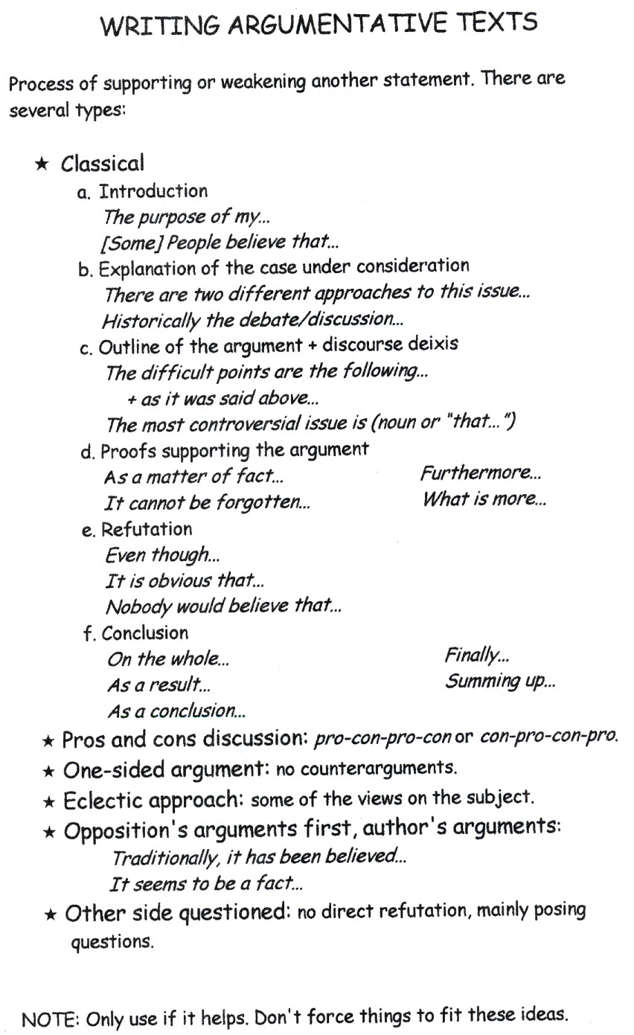

 Choose a topic. Brainstorm on pros and cons. Select ideas and organize them. Make a scheme of your future essay. Show it to the teacher or a peer for criticism. Improve your scheme. Show it to the teacher, including the former drafts. Write your essay. Find an original title for it, and an informative subtitle.

Writing Rubric
(Assessment)
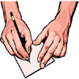
Name: _______________________________________________________________________________

Title of Work: __________________________________________________________________________
Teacher: www.teach-nology.com. Date Submitted: __________________

 | Criteria | Points

 | 1 | 2 | 3 | 4
Organization | Sequence of information is difficult to follow. | Reader has difficulty following work because student jumps around. | Student presents information in logical sequence which reader can follow. | Information in logical, interesting sequence which reader can follow.
Content Knowledge | Student does not have grasp of information; student cannot answer questions about subject. | Student is uncomfortable with content and is able to demonstrate basic concepts. | Student is at ease with content, but fails to elaborate. | Student demonstrates full knowledge (more than required).
Grammar and Spelling | Work has four or more spelling errors and/or grammatical errors. | Presentation has three misspellings and/or grammatical errors. | Presentation has no more than two misspellings and/or grammatical errors. | Presentation has no misspellings or grammatical errors.
Neatness | Work is Illegible. | Work has three or four areas that are sloppy. | Work has one or two areas that are sloppy. | Work is neatly done.
References | Work displays no references. | Work does not have the appropriate number of required references. | Reference section was completed incorrectly | Work displays the correct number of references, written correctly.
 |  |  |  | Total

Comments:

