Task-based Speaking Activity

Have a look at these two pages before starting. Three people are going to share a flat—you can be friends, students, people who can’t or don’t want to pay a whole rent by themselves, or people who need to leave their own houses because they have found a good job abroad and are moving temporarily. They have just moved in. They have to get organized, and adapt the house to their needs and lifestyles, they might be wanting to throw a New Apartment Party… Trying to keep in mind the structure of a dialogue (beginning, develop with balanced turn-taking, recapitulation and ending), deal with (some?, all? of) these issues.

The Flat
- How much is the flat? And the deposit?
- What is it like? (Imagine you show it to your friends)
- Where is it?
- Are there late night buses to the area? Are there any shops, parks, or services like a library, a sports center, etc.?

Sharing a flat
- How are you going to split the rent? Will you all pay the same or not?
- How will you distribute the rooms? How will you use the common rooms? Will you need to take turns? Will there be special hours for doing or not doing something?

How are you going to get organized?
- Will you share household and food expenses? Or will each pay for his or her own food, etc.?
- Paying the bills (electricity, water and gas bills)
- Social expenses: e.g. the party
- People staying over the night, or people coming over to visit.
- Dealing with the landperson (landlord/landlady)
How will you organize the housework and errands?
- Shopping
- Cooking and meals (times)
- Laundry and cleaning
- Buying things for the house: toilet rolls, light bulbs, a hammer, a screwdriver, a spanner, pliers, candles, matches, bin bags…
- Fixing things.
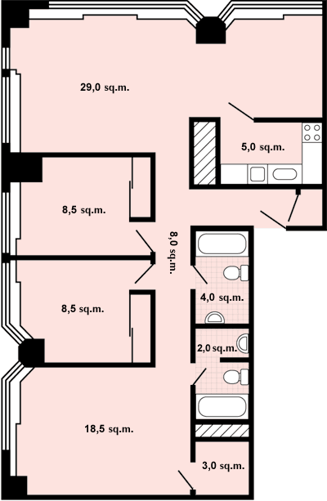

Organizing the party

Budget
Invitations: info (how to get there, time, address…)
Guests: who to invite
Food and drinks: shopping and splitting expenses
Music
Shows?
Activities?
Anybody staying over the night? (need sleeping bags or extra beds?)
Will you ask guests to help clean up the mess?
What’s in the house?
(Think about what you need to buy/fix + whether you need to call the landperson or not.)

BEDROOMS:
a King Size bed and 2 beds (no linen)
3 mattresses
a chest of drawers (in 2 of the rooms)
a wardrobe (only in 1 of the rooms)
a chair (only in 1 of the rooms)
a desk (in 2 of the rooms)
no table lamps
a wastepaper baskets
a bookcase (in 1 room)

KITCHEN:
a cooker with oven and grill
a fridge + freezer
rubbish bin (trash/garbage can, rubbish/litter/trash bin)
a dustpan and brush, and broom
a mop and bucket
a washing up bowl and rack
a fire extinguisher
a microwave
a washing machine
no crockery/cutlery/cooking pans; no table and chairs

COMMON ROOM:
it’s only got a settee/coach
BATHROOM
Mirror (fixed to wall)
Toilet brush and holder
Towel rail
Toilet roll holder
No shower curtain
A cupboard and storage space for shampoo etc.
GENERAL:
Filthy doormat
No curtains or blinds
No light bulbs and lampshades
Heating in every room
Ironing board (no iron)
Smoke alarm in hallway
No vacuum cleaner
The intercom doesn’t work

SPEAK ENGLISH ALL THE TIME!
Some sentences to help…

Starting…
So… here we are! New house, new life! (similar situational stuff)

Getting organized…
Hey, we could…
I can/could…
I’ll do it.
I’ll do that.
How about + …-ing?
Why don’t we…?
Let’s …
Wait a sec! Listen!
I’ve got an idea.
Where’s the …?
What about…?
Hold on!
That won’t work
Who can do this?
Who can be in charge of this?
Shall we…? (proposal)
Shall I…? (offering yourself to do something) – Shall I call the landperson?
Will you…? (asking somebody to do something)
That’d be great/lovely
It doesn’t make any difference (to me)
I don’t mind / It’s OK (with me)

Recap…
Who’s doing that?
Who’s getting that?
Who’s in charge of that?
Who’s calling whoever?

