PHONETICS  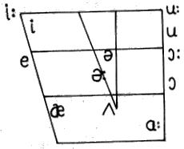 | 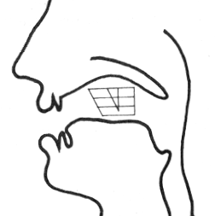 | The 24 consonant phonemes  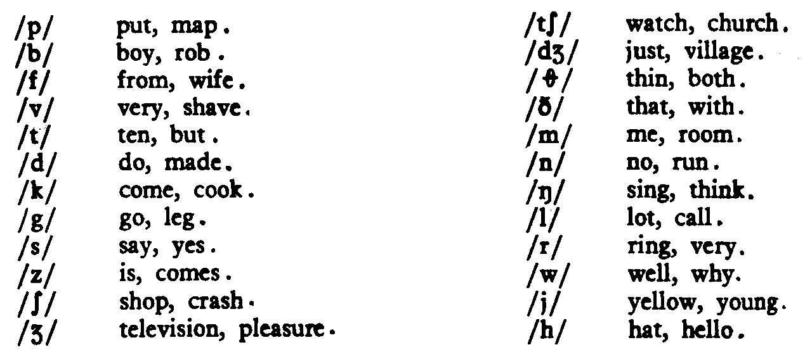
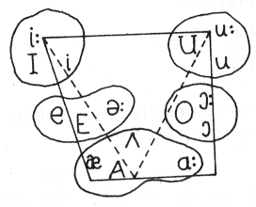 |  | The 12 vowel phonemes  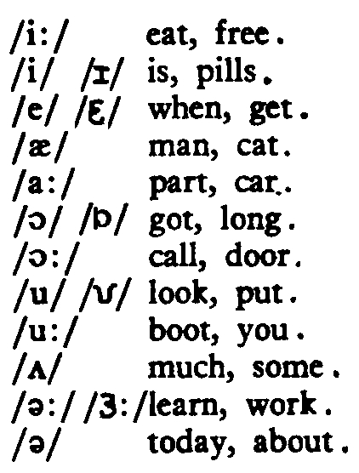 | The 8 diphthongs  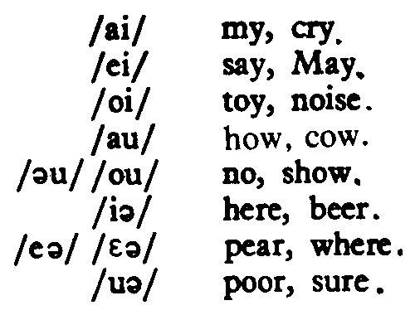

Minimal Pairs
Seat – sit
Eat - it
Cheap – chip
Leap – lip
Seen – sin
Feet – fit
Sheep – ship
Beach – bitch
Bean – bin
Green – grin
Pete’s – pits
Jean – gin
These – this
Team – Tim
Wheel – will
Peach – pitch
Teens – tins
Steal - still

bead – will – feel – wee – whipped - meal - thin – sin – sing – been – police - need - drink – tea – tin – it – fill – Jim – ink – this - meal – wheel – pin – steal – these – eat – think – money – minute – language – machine -

Unaccented support vowels: // //
// houses – horses – boxes – buses – sentences – phrases - fishes – finishes – teaches – reaches - Liz’s – boss’s ; wanted – waited – needed – regarded – jotted

seat – sit – set
bead – bid – bed
read – rid – red
wheel – will – well
feel – fill – fell
teams – Tim’s - Thames
seal – sill - sell

‘wen ‘ai wzin ‘mai ‘ti:nz ai ‘ju:st ‘sli:pin ‘big ‘bed ………………………………………………………………………………..
i ‘si:z ‘priti ‘igzin gri:n bin ……………………………………………………………………………………………………………………
it ‘i:ts ‘tu: ‘mt ………………………………………………………………………………………………………….…………………………………
ail ‘misju …………………………………………………………………………………………………………….…………………………………………….
‘aiv ‘bi:n ‘iki in ‘iz …………………………………………………………………………………………………………………….………………
‘aiv ‘bi:n ‘ikiin ‘i:z ‘pi:pl ………………………………………………………………………………………………………………………….
‘iziz ‘tu: ‘mt ………………………………………………………………………………………………………….………………………………….
‘i:za: tu: eg’spensiv ………………………………………………………………………………………………………………………..............
‘wts ‘iz? …………………………………………………………………………………………………………….……………….………………………….
‘wt ‘i:z? …………………………………………………………………………………………………………….………….…………………………….
‘wta: ‘i:z? …………………………………………………………………………………………………………….……………………………………….
hiz’stil ‘siti n  ‘bed ‘iki ’baut hiz ‘frendz …………………………………………………….……………………………….
i’sed i ‘wntid t ‘wt sm ‘futi: n ‘ti’vi ………………………………………………………………….………………………….
hi’sediwz ‘fedp wi ‘i:ti ‘bi:nzn ‘driki ‘ti: …………………………………………………….………………………………….
wi: ‘met ‘priti ‘bd ‘gai ………………………………………………………………………………………………………………………........

