My Template for Grammar Teams (Grammar in Use): prepositions 1

 | Grammar Teams. Prepositions  Read aloud everything  Find the correct preposition for each sentence  Say the completed sentences aloud
TIME (point in time): at, on, in
We could meet …………………… Monday
……………….. the afternoon I am always busy!
……………….. Tuesday afternoons I am always busy!
I was born ……………………………….. spring
We usually go on a holiday …………………….. August
My grandmother was born …………………….. 1936!
My plane leaves ………………….. 16.45
The movie starts ………………… six

Grammar Teams. Prepositions
Read aloud everything
Find the correct preposition for each sentence
Say the completed sentences aloud
TIME (extended period): since, for, by, from—to, from-until, during
I always go to the pool …………………………….. my summer holidays
I am going to Paris …………………….. two weeks!
My partner works …………………… nine ……………………………… three
On our exam day we have to be there …………………….. five
She hasn’t been here …………………… 2003
We have been here …………………… seven!
We have to hand in our essays …………………………….. next Tuesday
Wow! Julia! We haven’t seen each other …………………………. ages!

My Template for Grammar Teams (Grammar in Use): prepositions 2

Grammar Teams. Prepositions
Read aloud everything
Find the correct preposition for each sentence
Say the completed sentences aloud
PLACE (location): at, on, in
 | - Leave your essays ………………….. my desk  - Why don’t we put up that picture ………………… the wall?  - I live ………………………… 34 Picadilly Road  - I live ………………………….. Picadilly Road  - Let’s meet ……………………… the airport at six  - People are already ……………………….. the classroom  - I’ll wait for you …………………………… the bank  - We arrived …………………… London at midnight  - Loey arrived …………………. the concert hall too late.  - They’re already ……………………. the car  - They’re already ……………………. the bus
  
  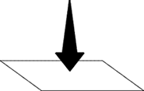
  

Grammar Teams. Prepositions
Find sentences for wording these pictures:
PLACE (spatial relationship)
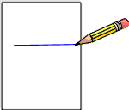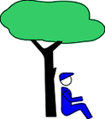
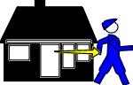 |  | 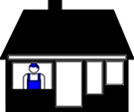 | 

