Vocabulary Worksheet no. 1 for Year 2

- Design an identity card. Use these words at least: Name (or Name + Surname), nationality, age, address, telephone no. (with area code), e-mail address, occupation, hobbies.

- In pairs or groups of three, how many family members can you name correctly (spelling them and pronouncing the whole word)?

- Parts of the body. Read aloud and translate the following words:
the cheeks, the chin, lovely ears, beautiful eyes, thick eyebrows, long eyelashes, the forehead, curly blond hair, the jaw, thin lips, a small mouth, a long neck, an interesting nose, sparkling white teeth, a sore throat!, the tongue, a sprained ankle, a strong arm, the back, a tiny bottom/ass, the chest, a hurt elbow, wrinkled fingers, smelly feet, tanned hands, a square head!, the heels, weak knees, short legs, wide shoulders, a bad stomach, the thighs, long thumbs, short toes, the waist, a sprained wrist.
- Describing people, physically. Read aloud and learn. Write and say similar descriptions.

- Mary is tall and thin with blonde hair. She’s about 23 and she is wearing jeans and a white T-shirt.
- Jane is tall and chubby. She’s a brunette. She’s a teenager. She is wearing jeans, too.
- Pete is a teenager with short curly dark hair. He is about 160 cm tall and has freckles. He is wearing a jumper, jeans and a pair of trainers.
- Ken is middle-aged and is of an average height. He’s bald and wears glasses. He’s wearing a blue suit.
- Muriel is in her thirties. She has short wavy blonde hair and wears glasses, too. She is wearing a red dress and red high-heeled shoes.
- Health. What’s the meaning of…?

My wrist hurts
I’ve got a terrible headache
I’ve got a pain in my arm
Does your tooth hurt yet?
It hurts lots / a lot
I’ve got a running nose. I need a hanky!
I’ve got a sore throat
I feel sick
I’m ill
I’m going to throw up!
How are you?
What’s wrong?

- Daily routines. Use the following verbs to write sentences. Use “I” and “(S)he” as subjects. Use some frequency adverbs and time phrases (always, often, usually… On Mondays, every day, in the morning, on Tuesday afternoon, once a week…).
I’m a ‘morning person’. The alarm goes off at 7:00. I wake up, and turn off the alarm. I get up quickly and go downstairs. I put on the coffee. I go back upstairs and have a shower. I sing a song in the shower. I put on my clothes. When I come downstairs again, I have my first cup of coffee. Mmmmm! Then I have some toast and a second cup of coffee. I wash my cup and tidy up the kitchen. I take my bag and set off to work. It is 8:00 am. I lock up the house before I go. Sometimes I run to catch the bus. I get on the bus and go for three or four stops. Then I get off the bus. I start my first class at 8:45am.

Brush one’s teeth / hair
Get dressed
Set the alarm-clock at…
Do the housework
Get up or wake up
Have a shower
Leave one’s house
Get home/ to work/school
Finish work/school
Have breakfast / lunch
Have a break
Have dinner
Meet
Watch TV
Lie on the couch
Go out
Go to bed
Catch/take the train/bus
Do some sport
Go dancing
Walk / Drive

Vocabulary Worksheet no. 2 for Year 2

- Describing people: character. Talk about people you know, i.e. My friend Maria, my uncle Tom…
beautiful, sociable, generous, good-looking, funny, untidy, happy, hard-working, intelligent, clever, lazy, mean, miserable, silly, ambitious, boring, imaginative, impatient, jealous, rude, patient, selfish, shy…
Opposites:

Mean ………………………………………………….
Funny …………………………………………………
Patient ………………………………………………..
Hard-working ………………………………………...
Tidy ……………………………………………………
Shy ………………………………………….…………
Miserable ……………………………….…………….
Polite ………………………………………………….

- My house and my kitchen. Find the names of the items in the picture. Write your descriptions.

My house
I live in quiet a big detached house. Downstairs there are four rooms altogether. As you come in through the front door, the first thing you see is a very big hall. At the end of the hall is a staircase leading upstairs. The first room on the right is the dining-room. Opposite this, on the left, is quite a large living-room. A door from the living-room leads to a small study. Opposite the study, next to the dining-room, is the kitchen. This is very big and very modern. It’s one of our favourite rooms. Upstairs there are three bedrooms. As you walk along the landing towards the front of the house, there are two bedrooms on your right and one on your left. Bedroom 1 is very large and has a balcony which overlooks the garden. We often have breakfast here in the summer. Bedroom 2 is in the front of the house and the third bedroom, which we use as a spare room, is opposite the bathroom. At the end of the landing, on the left, is a separate toilet.

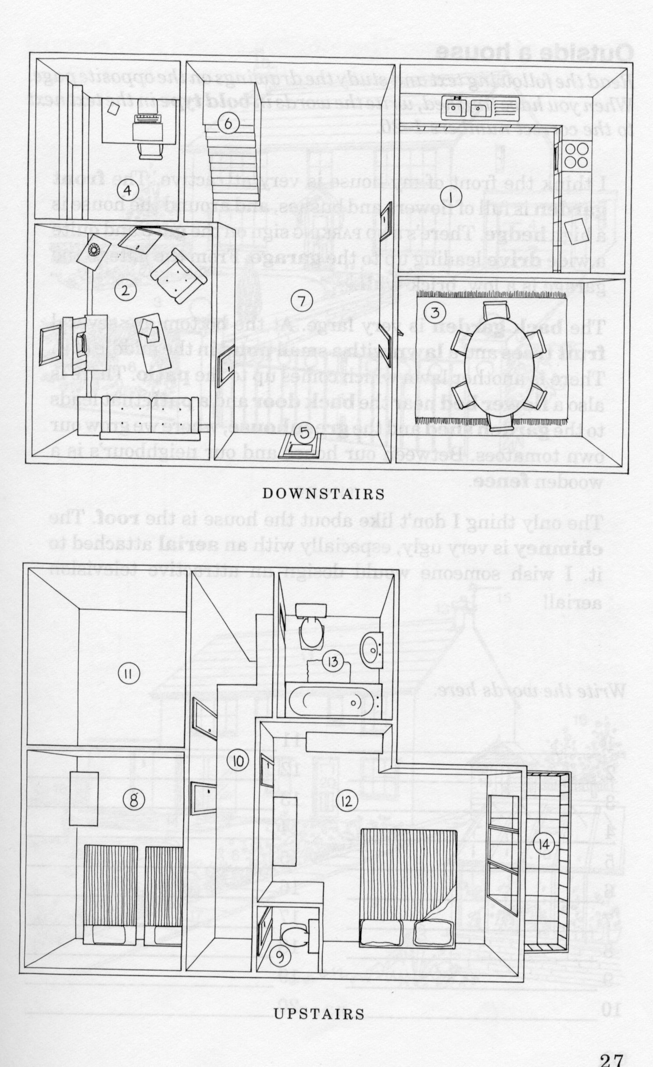
My kitchen is light and airy with white walls and lots of cupboards and shelves. There is a big fridge freezer in the corner covered in post-it notes and fridge magnets, and there is a washing machine and a dishwasher in the alcove at the back of the room. I have a lovely long work surface made of marble with lots of useful gadgets on it: a toaster, a teapot, a kettle, and a food processor. There is also a chopping board and a bread bin. The cooker is brand new. It’s got a grill, and a big oven. On the other side of the kitchen, beneath a window that overlooks the garden, the sink and draining board are made of stainless steel. There is a washing up bowl in the sink of course, and next to the sink there is a broom cupboard which is full of mops and buckets and an ironing board. Finally, tucked away in the corner, is the microwave, which, if I’m honest, is the thing that gets used most often in my kitchen.

What’s in your kitchen?
- cooker/stove
- cupboard
- cups
- dishwasher
- drawers
- forks
- fridge
- freezer
- ironing board

- frying pan
- glasses
- knives
- oven
- plates
- saucepans
- shelves
- spoons
- cutlery/silverware
- washing-up liquid/dishwashing liquid
- tea towel/dishcloth
- napkins
- sink
- breadboard
- tin operner/can opener
- corkscrew
- cloth
- food processor
- toaster
- washing machine
- scouring pad
- tap/faucet
- breadbin/breadbox
- microwave
- baking tray
- draining board
- (waste) bin/wastebasket
- fish slice/spatula
- serving spoon
- bowls
- wooden spoons
- pots and pans
- mop

