Iguazu Waterfalls
Learning Diary - My Oral Presentation
By Valéria Souza (AV2Tues, Course 2008-09)
Friday, 21st of November, 2008

When I came to Getafe from Vitoria and decided to enrol in the Advanced course at EOI (Avanzado 2), I thought that it would be difficult. At the beginning I felt afraid, not only because of the language but also because I didn’t know any of my classmates. The first day I went to class I felt like ”Oh. It’s too late for me. I can’t be with this group.” The reason was because when I got here the course had already started.
However, today I’ve had a great experience. It has been my first oral presentation. I’ve chosen the topic “Iguazu Waterfalls“ because we were told to chose a topic we loved to talk about. I have to say that the tip was really useful because I felt really comfortable while I was speaking. I also have to add that the atmosphere was perfect. My classmates were interested in what I was saying and the feedback was great. I started by offering an overview of what I was going to speak about. Then I developed the topic and at the end - after the feedback - I suggested a follow-up activity for the students who usually check out the forums on the TP eCampus.

I was wondering how to put my oral presentation in writing and decided to pretend that I’m a tourist guide that works at the Iguazu National Park.

Tourist guide: Welcome to the top destination for tourists in South America. Today, I’m going to give you some information about the Iguazu Waterfalls and then I’m going to interview a tourist that is going to tell us all about her experience here nine years ago. I hope you enjoy it. Let’s start!
The Iguazu Waterfalls extend over 2,700m — that is about 2 miles — and they’ve got a U shape. There are 275 falls. Many of them have got a name and the most impressive one is the Devil’s Throat Fall that is 80 meters high and the tallest.
The falls are located between Paraná in Brazil and Misiones in Argentina. There, in a subtropical rainforest, you’ll find two National Parks full of fauna and flora. As you can see in the map, the waterfalls are in the Northern part of Misiones and in the South western part of Paraná.

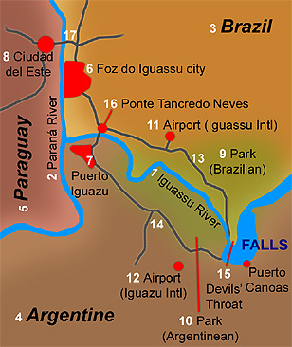

If you visit the Brazilian side, you’ll realise that the views are panoramic and if you visit the Argentinean side, you’ll be able to have a closer look at the falls and you’ll see that the trails are longer.
I have to tell you that Foz do Iguaçu is much more prepared to welcome tourists — there are more hotels and tour operators. However, this doesn’t mean that you can’t visit both — it’s actually very interesting to do so, and to note their differences.

Now, I’m going to give you some information about the Argentinean falls.

Your trip has to start at the Visitor Centre, where you get your ticket, which costs $10. The ticket allows you to visit the park, take two trains and a ferry to the very famous San Martin Island. If you don’t want to use your car to get there, you can take a bus. Each 45 minutes a bus leaves the main barrios of the city and it costs $1 per person. It’s possible to hire bilingual guides to learn about the falls. You can also do all the trails on your own. The park offers many services such as restaurants, shops, an amphitheatre and a place devoted to the ecosystem, where you have the opportunity of learning about the local fauna and flora. Another interesting activity is a show in Spanish by indigenous artists that takes part in the amphitheatre.
In the park you have three different circuits. The Upper Circuit, the Lower Circuit and the boat trip to the Devil’s Throat. To complete the Upper Circuit you have to walk for one hour in a 1,200 metre trail. If you take this circuit you’ll go into the jungle. There are no stairs, though — which means that’s less difficult! The Lower Circuit is a bit more difficult because you have to walk for about 2 hours along a kind of a walkway that has got stairs. You’ll also go into the jungle and you’ll have the opportunity of taking wonderful pictures because there are many balconies. In both circuits you are in touch with local fauna and flora. Finally, if you are brave enough you can take a boat to Devil’s Throat. Remember that it’s a powerful fall — it’s 80 metres high, it’s full of misty clouds from the water spray and the noise of the waterfall is deafening. I’m sure that if you like adventure you’ll have fun.

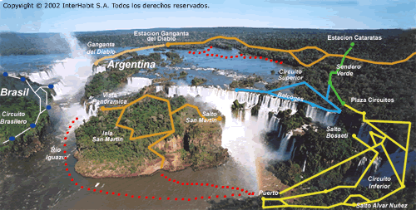

Now let me give you some information about the Brazilian part of the falls.

The trip also starts at the Visitor Centre, which is 20 kilometres away from Foz do Iguazu. The price is $4 per person and this includes a sightseeing tour by bus and access to the trails. If you take the bus, the first stop will be at the Macuco Fall, that is a 25 metre fall. There is the possibility of taking a boat to the base of this fall. The bus stops at the most important falls and you’ll have a great time because the bus also stops at the top of Devil’s Throat. At the end of the trip the bus takes you to Porto Canoas, a place where you’ll find souvenirs, toilets and fast food restaurants. There are special services for disabled tourists and you can also find medical assistance.

To finish this time with you I’ll ask a Brazilian visitor to tell us about her experience when she came here for the first time.

Tourist guide: Hello! I’d like you to tell us about your previous trip here.
Tourist: Hi! Sure! I came here for the first time nine years ago with some Spanish friends, my boyfriend — that is now my husband — and who is also Spanish and my sister. I have to tell you that it was an amazing experience. We were staying really far away from here, though. Actually, we had to drive for 14 hours to get here! Well, we decided to come in our own car so as to stop at different cities on our way. Oh! I forgot to tell you the name of the city — we were staying at Sao Paulo.
Tourist guide: Yes, Sao Paulo is really far away. So tell us a bit about the trip to the waterfalls.
Tourist: Ok. We arrived at Foz do Iguaçu at night, so we went straight to a hotel, we looked for a hotel near Paraguay because we also wanted to visit this side of the Falls. Then we had a shower and went out dancing. I felt like — oh! nothing special, really. It was a very expensive place but a normal one. Then on the first day of our stay there, we went to the falls on the Brazilian side. At that time we were allowed to enter the park in our car. It was an unforgettable experience because when we drove in all the windows of our car were closed and when we opened the doors... My God! We were amazed by the beauty of the landscape. I’d like to tell you an anecdote with the caotis — a typical animal — that are all over the park. We didn’t know that they were so naughty, so we did not lock the car doors and guess what? They got into the car and ate all our snacks. The coatis even peeled the wrapper off some of them! It was incredible. As we were so captivated by the waterfall we didn’t mind the coatis’ misbehaviour!

(On the webpage, two videos of coatis in action!)

Tourist guide: That’s really funny!
Tourist: So, after sightseeing using the trails and the platform, we took a helicopter to have an overview of the park. This was gorgeous. Especially Devil’s Throat. We couldn’t believe how enormous it was. After this, we had lunch at a local restaurant in the park. It was perfect. In the background, you could listen to the tropical birds singing. It was wonderful.
Tourist guide: What about the Argentinean part? Did you enjoy your time there?
Tourist: Sure! We went there on our third day and we spent three hours walking in the trails and the walkways. It was a great adventure when we took a boat to Devil’s Throat. I was scared to death because I can’t swim. When we finished the trip we had lunch in Argentina. I have to say that it was very expensive. As we were on holiday, we didn’t mind though.

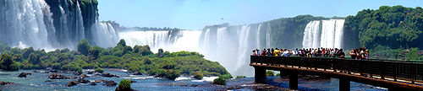
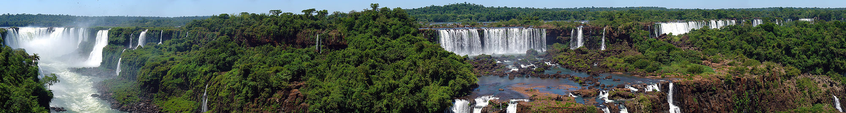

Tourist guide: So then I suppose your trip ended up there, didn’t it?
Tourist: No, it didn’t. On our fourth day we went to Paraguay. We crossed the frontier on foot and saw lots of people crossing it on foot too so as not to pay tax. You see, if you drive you have to pay a tax. We bought some goods and souvenirs and visited the point where the three frontiers meet.
Tourist guide: Could you describe that?
Tourist: Sure! It is the place in Paraguay where two rivers — Iguaçu river and Parana river — meet. There are three stone pillars with the flag of the three countries — Paraguay, Brazil and Argentina. On our fifth day the only thing we could do was get back home. You know in our — our 14-hour journey!
Tourist guide: Oh! Thanks a lot for telling us all about your time here. I hope you enjoy this visit as much!
Tourist: You are welcome! I wish everybody could have the chance to come here and learn about what I consider one of the seven wonders of the world.

More…

Unesco’s video of the Iguazu National Park (Argentina)
http://whc.unesco.org/en/list/303/video
Unesco’s webpage for the Iguaçu National Park (Brazil)
http://whc.unesco.org/en/list/355

