The ENGLISH DEPARTMENT OF EOI GOYA LANGUAGE SCHOOL
is delighted to announce our I CONTEST OF CRITICAL WRITING

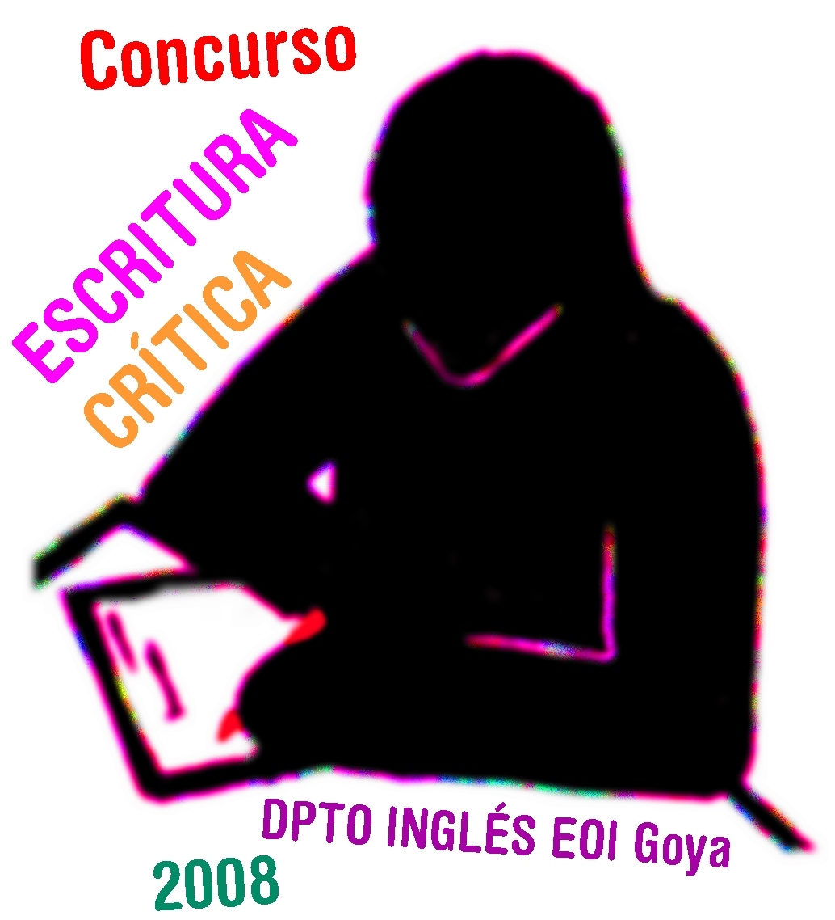

Students taking part will have to WRITE a CRITICAL COMMENTARY on
WILKIE COLLINS’S “THE WOMAN IN WHITE” in 580-600 WORDS

THINK about your text till MARCH 31 or APRIL 1
On these dates you will have to write your comment in class
The ESSAYS will be published on our READING CLUB blog
where people in love with literature meet
and where you can find more info on this contest
The award money…
First prize: 200€ * Second prize: 150€ * Third prize: 100€

On APRIL 25 writer ÁLVARO POMBO will visit our school
to give the awards (and we can ask him for his autograph)

